|  |  |  |  |  |
| --- | --- | --- | --- | --- |
| **Level 4th Unit 2**  **Scope and Sequence** | | | | |
| **Scenario: Natural Treasures** | | | | |
| **Enduring Understanding** | National parks provide homes and food to animals and jobs, education and entertainment for people. | | | |
| **Essential  Question** | Why do national parks matter to us? | | | |
| **Assessment and Goals** | | | | |
| **Week 1** | **Week 2** | **Week 3** | **Week 4** | **Week 5** |
| **Theme**   1. Places and People at the Park | **Theme**   1. Wildlife at the Park | **Theme**  3. A Trip to a National Park | **Theme**  **4.** Protecting our National Parks |  |
| **Assessment:**  **L.1**. Recognizes short and clear explanations when delivered slowly.  **R.1**. Recognizes much of what is written in short, simple texts on subjects with which they are familiar and/or in which they are interested.  **R.PA.1**. Distinguishes short vowel sounds in medial positions of words.  **SP.1.** Expresses common feelings during an oral presentation.  **Goals:**  **L.1**. understand short and clear explanations when delivered slowly (e.g The description of a national park).  **R.1**. understand much of what is written in short, simple texts on subjects with which they are familiar and/or in which they are interested.  **R.PA.1**. distinguish short vowel sounds in medial positions of words.  **SP.1**. express common feelings. | **Assessment:**  **L.2**. Recognizes the main points in short, simple stories and reports.  **R.PA.1**. Distinguishes short vowel sounds in medial positions of words.  **SI.1**. Asks  straight forward questions in familiar situations and understands the responses in an info-gap activity.  **Goals:**  **L.2**. understand the main points in short, simple stories and reports when there is some previous understanding of the topic and if they are read slowly, clearly and possibly repeated and accompanied with drawings and/or diagrams.  **R.PA.1**. distinguish short vowel sounds in medial positions of words.  **SI.1**. ask straightforward questions in familiar situations and understand the responses. | **Assessment:**  **L.3**. Recognizes the most important points in a straightforward talk or presentation.  **R.2**. Comprehends a reading by analyzing it and enjoy texts.  **R.PA.2**. Reads words decoding English graphemes and phonemes using knowledge of phonemic awareness.  **SI.1**. Asks straightforward questions in familiar situations and understands the responses in an info-gap activity.  **W.1**. Engages in the writing process: pre-drafting, drafting when writing sentences.  **Goals:**  **R.2**. comprehend readings and enjoy texts.  **R.PA.2**. decode English graphemes and phonemes using knowledge of phonemic awareness.  **W.1**. engage in the writing process: pre-drafting, drafting.  **SI.1**. ask straightforward questions in familiar situations and understand the responses. | **Assessment:**  **R.3**. Follows a set of clear-cut instructions.  **R.PA.2**. Reads words decoding English graphemes and phonemes using knowledge of phonemic awareness.  **W.2**. Uses simple sentences and expressions to describe people and things.  **SI.2**. Exchanges information about everyday matters using simple vocabulary during dialogues and conversations.  **Goals:**  **R.3**. follow a set of clear-cut instructions, especially if there are pictures or diagrams to illustrate the most important steps.  **R.PA.2**. decode English graphemes and phonemes using knowledge of phonemic awareness.  **SI.2**. Exchanges information about everyday matters using simple vocabulary during dialogues and conversations.  **W.2**. use simple sentences and expressions to describe such things as their surroundings, their daily activities, and the people around them. | **Assessment**  **Instruments for Process/Product**  **Week 6**  **Suggested Integrated Mini project**   * **Mini book** |
| **Function**   * Describing people, places, and things | **Function**   * Asking for and giving information about places and things | **Function**   * Describing past experiences | **Function**   * Making suggestions |  |
|  |  |  |  |  |
| **Discourse Markers**  Linkers: Sequential - past tense  First, then, after that, finally | **Discourse Markers**  Linkers: Sequential - past tense  First, then, after that, finally | **Discourse Markers**  Linkers: Sequential - past tense  First, then, after that, finally | **Discourse Markers**  Linkers: Sequential - past tense  First, then, after that, finally |  |
| **Grammar & Sentence Frames**  Simple present using (S-V-C) pattern   * The beach is beautiful. * The mountain is steep.   There is/are with conjunctions and/or.   * In Manuel Antonio, there are monkeys, sloths and birds. * There are mountains and streams.   I Santa Rosa National Park you can visit the historical museum or the walk on the trails | **Grammar & Sentence Frames**  Simple present using (S-V-C) pattern   * A monkey has a long tail.   Simple present tense   * Monkeys eat bananas. * They climb trees. * Birds eat fruit.   Wh /information questions   * What is Tortugüero like? * What can you do at Rincón de la Vieja National Park? * How can we preserve/protect our parks? | **Grammar & Sentence Frames**  Wh- questions in past tense   * Which National Park did you visit last weekend? * What did you do at Tortugüero? * What did you see?   Yes/No questions in simple past   * Did you swim there? Did you see any animals? * Did you like it? | **Grammar & Sentence Frames**  Modal - should   * People should follow the rules of the park. * Visitors’ shouldn´t throw garbage on the paths. * We shouldn´t feed animals there.   Simple past tense regular and irregular   * I went to Rincón de la Vieja in July. * I hiked to a waterfall. * I swam in the hot spring. |  |
| **Phonemic Awareness**  Short vowels:   * **/ æ /sad, fat, am,** * **/e /dress, went, ,red** | **Phonemic Awareness**   * Short vowels: * **/ı /pig, thin, fish** * **/ a /hot, pot, lot** * **/ ʌ / sun, fun, cut** | **Phonemic Awareness**  Identifying short vowel sounds **(-at, -in, -ot) in orally stated single-syllable words. (e.g., hen, hat, mad, hot.)** | **Phonemic Awareness**  Identifying short vowel sounds **(-at, -in, -ot) in orally stated single-syllable words. (e.g., hen, hat, mad, hot.)** |  |
| **Vocabulary**  1.Places and people at the park  National park   * Landmarks * Wildlife, forest * Warning signs * Restrooms * Picnic areas   Descriptive adjectives   * Clean * Peaceful   People at the park   * park ranger * tour guide | **Vocabulary**  2.Wildlife at the park   * Turtles * Sloths, Monkeys * Snakes, Squirrel * Parrots, Scarlet macaws, crabs * Crocodiles,   raccoon | **Vocabulary**  3. A Trip to a National Park  Activities in past tense:   * Saw, Went * Ate, swam * Took, walked * Watched, visited * Listened, learned | **Vocabulary**  4. Protecting our National Parks   * Do not litter. * Do not feed the animals. * Do not pollute water. * Do not kill animals or destroy plants and trees. * Protect the wildlife. * Preserve nature. |  |
| **Psycho-social**   * Taking personal and social responsibility to care for nature.   **Sociocultural**   * Using the right choice of greetings & address forms (e.g. “High fives” and “fist bumps”)   **Idioms/phrases**   * Proverbs/idioms: * “A breath of fresh air…” ( something new or different makes the experience more exciting) | **Psycho-social**   * Taking pride in natural treasures in our country.   **Sociocultural**   * Following conventions for turn taking   **Idioms/phrases**   * Proverbs/idioms: * “A breath of fresh air…” ( something new or different makes the experience more exciting) | **Psycho-social**   * Working cooperatively with others.   **Sociocultural**   * Following conventions for turn taking   **Idioms/phrases**   * “When it rains, it pours.” (When something good or bad occurs, it usually occurs more than once.) | **Psycho-social**   * Working cooperatively with others.   **Sociocultural**   * Using the right choice of interjections (e.g. Oh! Wow! Beautiful!)   **Idioms/phrases**   * “Have the time of my life” ( to enjoy an experience very much) |  |

|  |  |  |  |  |
| --- | --- | --- | --- | --- |
| **Scenario/ Themes** | **Dimensions** | | | |
| **No. 2 Natural Treasures** | **1.** **Ways of thinking** | **2. Ways of living in the world** | **3. Ways of relating with others** | **4. Tools for integrating with the world** |
| 1.  Places and People at the Park | X | X | X | X |
| 2.  Wildlife at the Park | X | X | X | X |
| 3.  A trip to a National Park | X | X | X | X |
| 4.  Protecting our National Parks | X | X | X | X |

|  |  |  |  |  |  |  |  |  |  |
| --- | --- | --- | --- | --- | --- | --- | --- | --- | --- |
| **Term: I** | | **Level: Fourth Grade** | | | **Unit:2** | | | **Week:1** | |
| **Domain: Socio-Transactional** | | | | **Scenario: Natural Treasures** | | **Theme: Places and People at the Park** | | | |
| **Enduring Understanding**: National parks provide homes and food to animals and jobs, education and entertainment for people. | | | | | | | | | |
| **Essential Question:** Why do national parks matter to us? | | | | | | | | | |
| |  | | --- | | **Dimensions** | | **1.** **Ways of thinking ( X )** | | **2. Ways of living in the world ( X )** | | **3. Ways of relating with others ( X )** | | **4. Tools for integrating with the world ( X )** | | | | | | | | | | |
| **Learn to Know** | | | | **Learn to Do** | | **Learn to Be and Live in Community** | | | |
| **Grammar & Sentence Frames**  Simple present using (S-V-C) pattern   * The beach is beautiful. * The mountain is steep. * The Forest is...   There is/are with conjunctions and/or.   * In Manuel Antonio, there are monkeys, sloths and birds. * There are mountains and streams. * Santa Rosa National Park you can visit the historical museum or the walk on the trails   **Phonemic Awareness**  Short vowels:  / æ /sad, fat, am,  /e /dress, vest, ,red  **Vocabulary**  1.Places and people at the park  National park   * Landmarks * Wildlife, forest * Warning signs * Restrooms * Picnic areas   Descriptive adjectives   * Clean * Peacefuleople at the park * park ranger * tour guide | | | | **Function**   * Describing people, places, and things   **Discourse Markers**  Linkers: Sequential - past tense  First, then, after that, finally | | **Psycho-social**  Taking personal and social responsibility to care for nature.  **Sociocultural**  Using the right choice of greetings & address forms (e.g. “High fives” and “fist bumps”)  **Idioms/phrases**  Proverbs/idioms:  “A breath of fresh air…” ( something new or different makes the experience more exciting) | | | |
| **Assessment Strategies & Indicators of learning**  (Diagnostic, formative, summative) | **Goals** | | | **Pedagogical Mediation/ Didactic Sequence** | | | | | **Time** |
| Learner…  **L.1**. Recognizes short and clear explanations when delivered slowly.  **Indicator of learning:**  Recognizes short and clear explanations about Costa Rica National Parks, when delivered slowly.  **R.1**. Recognizes much of what is written in short, simple texts on subjects with which they are familiar and/or in which they are interested.  **Indicators of learning**  Recognizes much of what is written in short, simple texts about national parks.  **SP.1.** Expresses common feelings during an oral presentation.  **Indicator of learning:**  Expresses how national parks make them feel, during an oral presentation.  **R.PA.1**. Distinguishes short vowel sounds in medial positions of words.  **Indicators of learning:**  Distinguishes short vowel sound /**e**/ in medial positions of words.  Distinguishes short vowel sound /**æ**/ in medial positions of words. | Learner can …  **L.1**. understand short and clear explanations when delivered slowly (e. g The description of a national park).  **R.1**. understand much of what is written in short, simple texts on subjects with which they are familiar and/or in which they are interested.  **SP.1.** Express  common feelings during an oral presentation.  **R.PA.1**. distinguish short vowel sounds in medial positions of words. | | | **Pre-teaching**  **Routine:** Checking attendance, checking in with Ls, T posts the Essential Question on the board, Can Do’s, and class agenda, etc.  **Essential Question:** Why do National Parks matter to us?  **Warm up**  Then, teacher shows the YouTube video: **Costa Rica: A Little Piece of Paradise | National Geographic** <https://www.youtube.com/watch?v=qTnTlECDO6w>and asks learners to take notes on the natural beauties they recognize**.** Learners share their list in pairs, and then with the whole group.**Activation of prior knowledge**  Learners get together in a circle. Teacher asks the students to play “*Jump in - Jump out*” (learners jump in for yes and stay out for not). Learners observe the teacher as she shows the pictures of different animals and natural beauties and asks them: Is this a monkey? Is this a beach? Is this a river?, etc. If the answer is yes, learners jump in; if the answer is not, learners stay out of the circle.  **Modeling**  Teacher shows a video about Manuel Antonio National Park.  <https://www.youtube.com/watch?time_continue=79&v=RwOzMG3J65E> As the learners watch the video, the teacher describes what they see in the video by saying, “In Manuel Antonio, there are adventure activities tourists can practice; there are animals, etc.  Then, Teacher reinforces the sentence frames related to National Parks by using a PPT. <https://docs.google.com/presentation/d/1zRjBePl3HWuP4BVgtdah6e7Bc5-_zqzZyJJktOM4ALQ/edit#slide=id.g60c4b4d299_0_218>  **Example:** In Manuel Antonio **there is** lots of wildlife like monkeys, sloths and birds. T**here are** mountains, forests and peaceful streams. Then, a tour guide can help you to find the restrooms, picnic areas, warning sites and clean beaches.  **Clarifying**  Using the same images from the PPT of the previous activity, the teacher clarifies vocabulary and expressions by describing a picture and the students guess what the picture is using their knowledge of the vocabulary words. The teacher can write the names of the pictures on the board and the students can use those to help guess the pictures. For example, the teacher says: “T*here are two sandy beaches at Manuel Antonio*” and the learners point to the picture being described.  <https://docs.google.com/presentation/d/1zRjBePl3HWuP4BVgtdah6e7Bc5-_zqzZyJJktOM4ALQ/edit#slide=id.g60c4b4d299_0_218>  **Pre-task**  Teacher reviews the support language by drawing pictures on the board and having students guess what the drawing represents. For example, the teacher says “*What animals and natural beauties are there in Manuel Antonio?* and then draws “sloths” and the learners say “*There are slots in Manuel Antonio*. ”Next, the teacher draws two beaches and the learners say “*There are sandy beaches in Manuel Antonio*” and so on.  The teacher also reviews key vocabulary about outdoor activities such as: horseback riding, hot springs, and hiking in the trails.    **Task rehearsal**  Learners observe the teacher as he/she draws a big rectangle on the board. Learners listen to the teacher talking about the beauties and activities found at a National Park in Costa Rica. As they listen, volunteers go to the board and draw what the teacher explains.  E.g. *In Arenal Volcano National Park, there is a volcano. There are monkeys and iguanas. There are hiking trails and hot springs..*  Volunteers take turns to draw, so class participation is maximized. Also, peer correction is encouraged.  **Task completion**  Learners get a blank piece of paper. Learners listen to the teacher talking about the beauties and activities found in a National Park in Costa Rica. As they listen, learners draw what the teacher explains.  E.g. *In Rincón de la Vieja National Park, there is an active volcano. There are waterfalls and trails to walk in the forest.*  Teacher monitors the learner's performance of the task.  **Task assessment**  Teacher shows a poster of a National park. In pairs, Learners make an oral performance regarding what they see in that picture. Using sentence frames: In \_\_\_\_\_\_\_\_ National park, there are\_\_\_\_ or there is a\_\_\_\_.  **Pre-task**  Teacher shares the goal of the lesson with the students. Teacher uses a poster about Manuel Antonio National Park in order to review vocabulary and structures.    E.G: In Manuel Antonio there is\_\_\_\_\_\_\_, there are\_\_\_\_\_\_\_\_\_, Also you can find\_\_\_\_\_\_\_\_\_\_\_.  Also, the teacher introduces vocabulary: ziplining, white water rafting, canyoning, hanging bridges and horseback riding, by means of pictures.  **Task-rehearsal**  Learners observe the teacher as she/he sticks the reading below on the board. Then, the teacher explains that he/she is planning to go to Arenal Volcano National Park, and he/she is reading information about it.  Arenal Volcano National Park is in the northern area of Costa Rica. The main town near the park is La Fortuna.  There are 2 volcanoes in this national park – Arenal and Cerro Chato. Arenal used to be Costa Rica’s most active volcano whereas Cerro Chato is completely dormant.  Outside the national park are tons of fun activities including hot springs, La Fortuna waterfall, ziplining, white water rafting, canyoning, hanging bridges and horseback riding.  The learners read the text along with the teacher, and the teacher writes different statements and learners have to decide whether the statements are true or false depending on the reading. If the statement is true, learners show their thumbs up; if the statement is false, learners show their thumbs down.  E.g. T*here is one volcano in Arenal National Park. True or False*  *There are hot springs in Arenal National Park. True or False*  *There are beaches at Arenal National Park True or False*  Anytime learners answer a True or False statement, a volunteer goes to the front and points out the place in the reading where the answer is found.  **Task-completion**  Students answer correctly 5-6 true/false questions based on a reading about Manuel Antonio National park. The task is available at [https://docs.google.com/document/d/1fO4i9w-n1CWc4ss-u46rtPQjTE-ON5oY4QRZ23C77wg/edit#](https://docs.google.com/document/d/1fO4i9w-n1CWc4ss-u46rtPQjTE-ON5oY4QRZ23C77wg/edit)  **Task assessment**  Students play the park battle game available at  <https://docs.google.com/document/d/1BYbhf2EYMIp5UyNuMAh8EPeb778hQ_Nx/edit>  **Post Task**  Teacher pastes pictures around the classroom, representing Manuel Antonio National Park.  Then, Teacher gives the learners a tour to Manuel Antonio. Learners are going to watch wildlife and common places and areas found in the park, then the teacher encourages learners to use sentence frames, orally.      **Pre-task**  Teacher shares the goal of the lesson.  Teacher shows a map and some flashcards about national parks. <https://drive.google.com/drive/folders/1xU1oAIOyMskSyFRgf24iPFAXscyL1F2j> As the learners see the pictures, teacher talks about the animals and activities in each place, and how the place makes him/her feel.  For example:  “*This is Cahuita National Park. In Cahuita there is a beautiful beach and a forest. People can swim and enjoy the sandy beach too. In the forests, there are toucans and sloths.* ***This place makes me feel happy and relaxed.***  Teacher reviews some useful feelings: calm, peaceful, exciting, boring, relaxed, happy, and uses them to describe places.  “**T*his place makes me feel calm.”***  **Task-rehearsal**  Learners play national park memory game. As students play the game, they can talk about what they see in the picture, how that makes them feel and if they want to go to the place. online: <https://www.freememorygame.com/?dn=CR_NATIONAL_P>  **Task completion**  Learners are assigned one of the pictures from the PPT used in the pre-task (pictures are pasted all around the classroom). Using one of the pictures as a stimulus, learners talk about what they see in the picture, and what the place makes them feel. To do so, the class is divided into two groups. The first group talks about the picture and the others listen (Gallery Walk), and then learners switch roles.  The teacher monitors the performance of the students.  **Task assessment**  Teacher asks the students to get in a circle to play the spinner magic bottle. Someone spins the bottle, and when it stops, the student who the lid is pointed to has to say: *“My favorite National Park is \_\_\_\_\_\_\_\_\_\_\_\_\_\_. In \_\_\_\_\_\_\_\_\_\_\_\_, there is \_\_\_\_\_\_\_\_ / there are \_\_\_\_\_\_\_\_\_\_\_. This place makes me feel\_\_\_\_\_\_.”*  Teacher provides oral feedback.  **Pre-task**  Teacher introduces the goal of the lesson.  Learners observe the teacher as she locates a box on a table. Then, the teacher explains that inside that box there are three sounds, and pictures representing those sounds. The teacher takes each sound, pronounces it, and shows pictures that include the specific sound in medial position. Learners are asked to repeat the pronunciation of each sound and word after the teacher twice.  **Task-rehearsal**  Learners listen to a set of words and identify the common short vowel sounds while they point to the pictures that represent the sound heard.  Teacher mixes the cards, and then learners select a picture card and say the word aloud to place it in the correct **vowel sound (phoneme)** chart on the whiteboard. Example:    Students listen to the middle vowel sound. Say the words aloud and they circle the right picture. Example:      **Task completion**  Learners draw lines connecting the vowel sound **/e/** and **/æ/** to the pictures that have the same sound in the middle. They use a different color pencil for each sound.  **Task assessment**  Students listen to a short story that contains the words studied and read it along with the teacher and then on their own.  *Story:* ***A fat cat had a red dress. The red dress was very small so the cat got sad and went home*** | | | | |  |
| **Integrated Mini-Project** | | | | | | | | | **Time** |
| * **Planning:** The class is divided into groups of three. Learners are told they are tourist guide going to a tourist fair. They have to advertise the beauties found in Costa Rica National Parks. Each group decides on a National Park they would like to create a poster about and the information they would like to include. * **Creating:** Learners design their poster. * **Rehearsing:** Learners rehearse their presentation * **Participating:** Learners present their poster orally: self and peer assessment | | | | | | | | | Learners present their poster orally in week 5 or 6 |
| **Reflective Teaching** | | | | | | | | | |
| What worked well | | | What didn’t work well | | | | How to improve | | |
| **Enduring Understanding Reflection** | | | | | | | | | |
|  | | | | | | | | | |

|  |  |  |  |
| --- | --- | --- | --- |
| **Learner Self-Assessment** | | | |
| ***I can…*** | ***Yes*** | ***Sort of*** | ***No. Help!*** |
| Recognize short and clear explanations about Costa Rica National Parks, when delivered slowly. |  |  |  |
| Recognize much of what is written in short, simple texts about national parks. |  |  |  |
| Express feelings about how national parks make them feel, during an oral presentation. |  |  |  |
| Distinguish short vowel sound /**æ**/ in medial positions of words. |  |  |  |
| Distinguish short vowel sound /**e**/ in medial positions of words. |  |  |  |

|  |  |
| --- | --- |
| **Pictures about Manuel Antonio** | |
|  |  |
|  |  |
|  |  |

**Arenal Volcano National Park**

Arenal Volcano National Park is in the northern area of Costa Rica. The main town near the park is La Fortuna.

There are 2 volcanoes in this national park – Arenal and Cerro Chato. Arenal used to be Costa Rica’s most active volcano whereas Cerro Chato is completely dormant.

Outside the national park are tons of fun activities including hot springs, La Fortuna waterfall, zip lining, white water rafting, canyoning, hanging bridges and horseback riding.

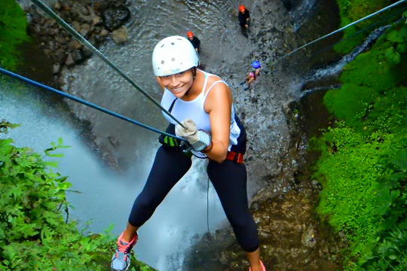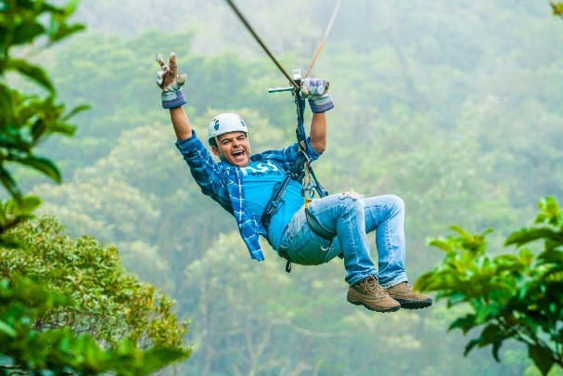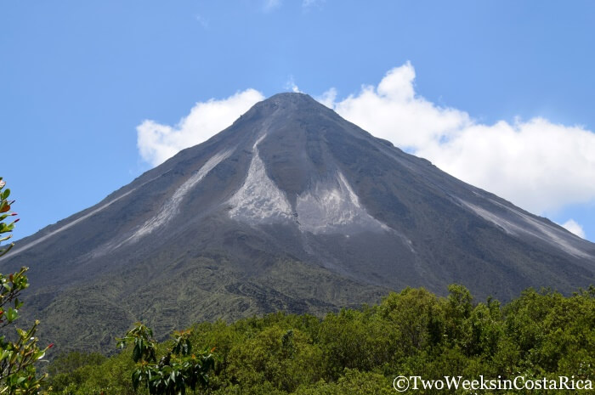

Directions: Diane is a tourist guide. She is preparing information about Manuel Antonio National Park in order to share it with tourists. However she is not sure if all the information is correct. Please, read the text and answer true if the information is correct or false if the information is not correct

Manuel Antonio National Park

Manuel Antonio is a beautiful National park. It is located on the Pacific coast in Quepos Puntarenas. There is lots of natural beauties in Manuel Antonio.

In Manuel Antonio there are four beaches. In the sea there are dolphins and whales. There are crustaceans by the beach. There are beautiful landscapes in Manuel Antonio.

On the other hand, there is lots of biodiversity in Manuel Antonio forest. There are 109 mammal species and 184 species of birds. Besides, there are howler monkeys, squirrel monkeys, and spider monkeys in manuel Antonio

Manuel Antonio is a beautiful National park

# **Answer “true” or “false”**

1. Manuel Antonio is located in the Athlantic coast of Costa Rica: \_\_\_\_\_\_\_\_\_\_\_\_\_\_
2. There are four beaches in Manuel Antonio: \_\_\_\_\_\_\_\_\_\_\_\_\_.
3. There are dolphins in the sea of Manuel Antonio: \_\_\_\_\_\_\_\_\_\_\_\_\_.
4. There are 109 species of birds in Manuel Antonio: \_\_\_\_\_\_\_\_\_\_\_\_.
5. There are spider monkeys and birds: \_\_\_\_\_\_\_\_\_\_\_.
6. There are not howler monkeys in Manuel Antonio\_\_\_\_\_\_\_\_\_\_\_\_.

Park Battle game

General directions:

1. Two players

3. Give a copy to each player. (The opponent cannot see other’s handout)

2. Each player chooses a number and mark it with an (X)

3. Play rock, paper and scissors in order to define who will the first player be.

4. Take turns saying: ***I am shooting you at….*** (add one number trying to guess your opponent position). Use there is or there are plus ta sentence after saying I am shooting you at. For example; I am shooting you at ***There are Guanacaste trees in Santa Rosa***

5. The players should mark the coordinates that have already been shot in order to avoid repetition

6. When a player shoots at one of the opponent’s coordinates; the opponent should say the phrase “There is a player out of the game” in order to let their opponent know that has shot the goal

7. The first player to shoot at the opponent’s mark will be the winner

8. If there is enough time you can start the game again or play against a different opponent.

**I am shooting you at: there is/are \_\_\_\_\_\_\_\_\_\_\_\_\_\_\_\_\_\_\_\_\_\_\_\_\_ in \_\_\_\_\_\_\_\_\_\_\_\_\_\_\_\_\_\_\_\_\_\_\_.**

**(thing/animal from the box) (name of park from blue boxes)**

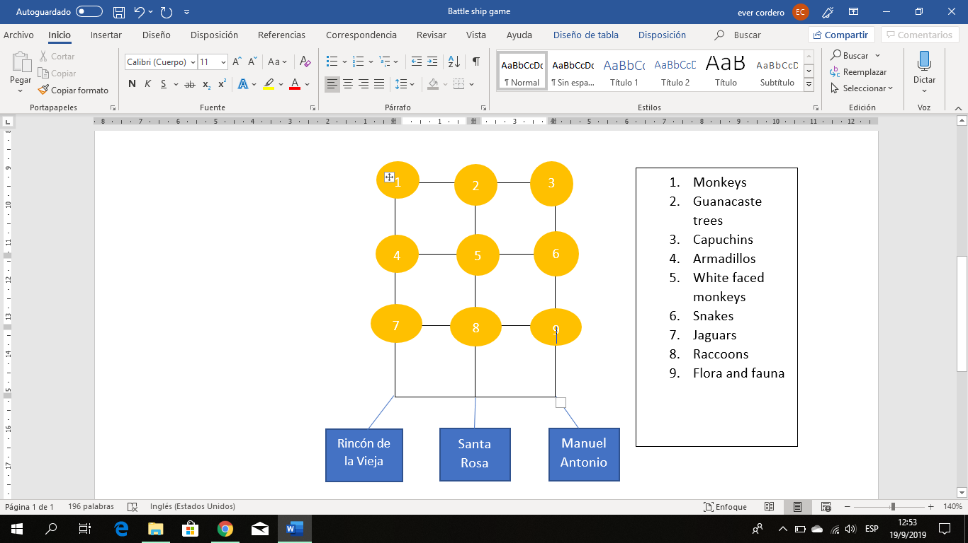

|  |  |  |
| --- | --- | --- |
|  |  |  |
|  |  |  |
|  |  |  |
|  |  |  |

**National Parks Memory game 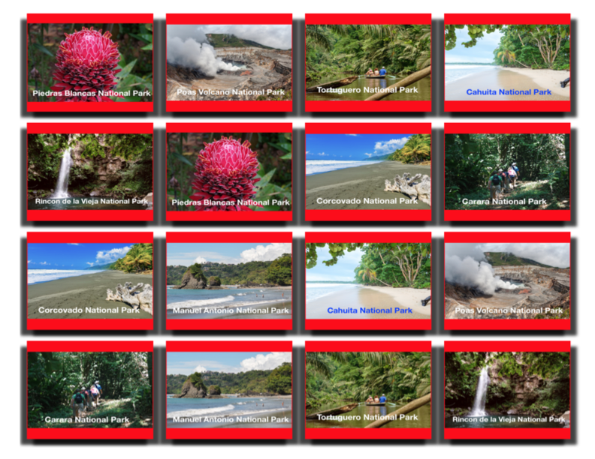**

Draw lines connecting the vowel sound **/e/** and **/æ/** to the pictures that have the same sound in the middle. Use a different color pencil for each sound.

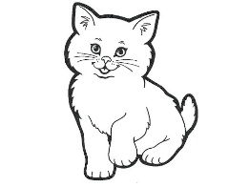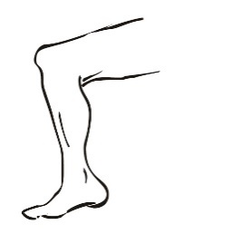****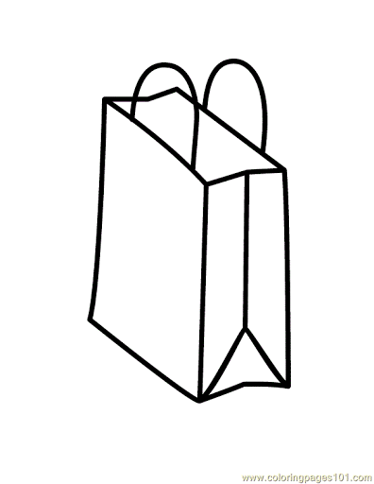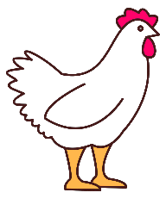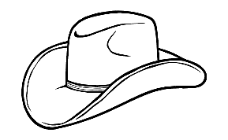 **/e/ /æ/**

Draw lines connecting the vowel sound **/e/** and **/æ/** to the pictures that have the same sound in the middle. Use a different color pencil for each sound.

**** **/e/ /æ/**

|  |  |  |  |  |  |  |  |  |
| --- | --- | --- | --- | --- | --- | --- | --- | --- |
| **Term: II** | **Level: Fourth Grade** | | | **Unit: 2** | | | | **Week:2** |
| **Domain: Socio-transactional** | | | **Scenario: Natural Treasures** | **Theme: Wildlife at the park** | | | | |
| **Enduring Understanding**: National parks provide homes and food to animals and jobs, education and entertainment for people. | | | | | | | | |
| **Essential Question:** Why do national parks matter to us? | | | | | | | | |
| |  | | --- | | **Dimensions** | | **1.** **Ways of thinking ( X )** | | **2. Ways of living in the world ( X )** | | **3. Ways of relating with others ( X )** | | **4. Tools for integrating with the world ( X )** | | | | | | | | | |
| **Learn to Know** | | | **Learn to Do** | **Learn to Be and Live in Community** | | | | |
| **Grammar & Sentence Frames**  Simple present using (S-V-C) pattern  A monkey has a long tail.  **Simple present tense**  Monkeys eat bananas.  They climb trees.  Birds eat fruit.  **Wh /information questions**  What is Tortugüero like?  What can you do at Rincón de la Vieja National Park?  How can we preserve/protect our parks?  **Vocabulary**  Turtles, monkeys, sloths, snakes, squirrel, parrots, scarlet, macaws, crabs, crocodiles, raccoon, lizard, tiger, dolphin, bat, bug, white tail deer, quetzal, jaguar, birds, butterflies  **Phonology**  /i/ pig, thin, fish  /a/ Hot, pot, lot  /Ʌ/ Sun, fun, cut | | | **Function**  Asking for and giving information about places and things  **Discourse Markers**  Linkers: Sequential - past tense  First, then, after that, finally | **Psycho-social**  -  Taking pride in natural treasures in our country.  **Socio-cultural**  -  Following conventions for turn taking  **Idioms/phrases**    **-  Proverbs/idioms:**  -  “A breath of fresh air…” ( something new or different makes the experience more exciting) | | | | |
| **Assessment Strategies & indicators of learning**(Diagnostic, formative, summative) | **Goals** | | **Pedagogical Mediation/ Didactic Sequence** | | | | | **Time** |
| Learner…      **L.2**. Recognizes the main points in short, simple stories and reports.      **Indicator of learning:**  Recognizes the main points in short, simple stories about visits to National Parks.    **SI.1**. Asks straightforward questions in familiar situations and understands the responses in an info-gap activity.      I**ndicators of learning**   * Asks straightforward questions about Costa Rica’s national Parks in an info-gap activity * Recognizes what has been said about Costa Rica’s national parks in an info-gap activity.   **R.PA.1**. Distinguishes short vowel sounds in medial positions of words.    **Indicators of learning:**  Distinguishes short vowel sound **/a/** in medial position of words.  Distinguishes short vowel sound **/ʌ/** in medial position of words.  Distinguishes short vowel sound **/**ı/ in medial position of words. | Learners can…    **L.2**. understand the main points in short, simple stories and reports when there is some previous understanding of the topic and if they are read slowly, clearly and possibly repeated and accompanied with drawings and/or diagrams.    **SI.1**. ask straightforward questions in familiar situations and understand the responses.    **R.PA.1**. distinguish short vowel sounds in medial positions of words. | | **Pre-teaching**  **Routine:** Checking attendance, checking in with Ls, and class agenda, etc.  **Warm up**  Learners observe a poster of animals’ footprints. The teacher describes the animal and the students listen to the description. Then, they guess which animal’s footprint it is by identifying its shape.  <https://drive.google.com/open?id=13Yt1N1EnqetYt4L7kAsJCh6QEjOqslw->  <https://drive.google.com/open?id=1YWrkHm_a7Q9KSRnnFmD5IgCNbAbtwF9a>  https://lh5.googleusercontent.com/BCHPmpbgtBnCnlH0NdFTFimuovR1Ycj-Xvw-6yrtuxWZzXpIL_IjiZWc_SKehpva36Qrova1TZXMU_T_B3htFnKYCqKnUBZXGLAPkoNygMxH8ySvztiEj2nyPHzl7SLSvZPH208        https://lh4.googleusercontent.com/KKx2hOcAnupFwfnh1goQVynGPIoW23BP2MYpimwfRsz0yCbI-HFisWKVhOfoRTP7ESmzickUXUkKqxTCzDnLsDImaXTcqg8NZmdJ2B16yzbkgclISzwulgKzBDRVZD0Q_Ki1PMw  **Activation of Prior Knowledge**  Learners watch the following video:<https://www.youtube.com/watch?v=emIe_GO0hc8> As learners watch the video, the teacher mentions the name of the wild animals shown.  Teacher asks learners if they remember some of the animals in the video. Students brainstorm the names of the animals.  **Modeling**  Teacher uses pictures to present the new vocabulary and sentence frames about wild animals. Students participate in choral repetition. For example:   * *In the forest, there are parrots, scarlet macaws, and toucans. They are beautiful birds.* * *There are monkeys, raccoons, sloths, squirrels and lizards also.* * *In some National Parks, tourists can see white-tail deer, jaguars, and tigers.* * *In the rivers, people can see turtles and  crocodiles*   **Clarifying**  Teacher clarifies vocabulary and expressions by asking questions. (Is this a monkey? Is it black?) Learners answer the yes/no questions by saying Yes, it is. / No, it isn’t.  Learners play “I spy with my little eye”.  The teacher sticks the pictures of the wild animals on the board. Then, he/she divides the class into two teams. Each member of the team races to touch the animal the teacher says.  **E.g.**  Teacher: “I *spy with my little eye an animal that people can see in the forest .It is a bird. It is a parrot? ”I spy with my little eye a toucan.”*  The learners then run to touch the corresponding picture. The game continues until most students have participated.  Hint Animal Game (Animal charade) Teacher clips a picture of an animal on the back of each student. By taking turns, each student goes to the front. He / she turns around so the other students can look at the picture. Learners start acting out the animal behavior, for their friends to guess what animal it is.  **Pre-task**  Teacher shares the goal with students.  Teacher reviews the meaning of “first, then, after that, finally” by talking about his/her last visit to a National Park. For example, using pictures the teacher may say: “Last *December, I went to Juan Castro Blanco National Park. First, I walked the trails and I saw many species of birds flying .I saw a parrot, and a beautiful toucan. Then, as I kept walking, I heard monkeys yelling. After that,…”*  The teacher emphasizes on the key sequential words.  Teacher varies the pace, tone, and volume of voice, pausing where appropriate, as a way to catch the learner's attention.  **Task Rehearsal**  Learners close their eyes while the teacher plays a recording of nature music to create a feeling of being in a forest. As the music plays, the teacher tells learners a story of a trip he/she took. Then, using pictures, the teacher asks questions to the students:  **“Did** I go to Cahuita National Park/ Manuel Antonio National Park/ or Arenal Volcano National Park?  Did I see any animals? What did I see?”  **Task completion**  Learners listen to the story “**My Amazing Trip to Corcovado National Park.”** Then, they complete the worksheet below.  **Reminder**: Make sure learners read and understand the questions before listening to the story.   1. https://lh5.googleusercontent.com/bd0qeJ_pRJDMZv2A_2Rj9XwDdBgB5_roqosgRqmyBBH305t0R5wuMw1Ikii_ywMXJc4tccW0pDAzU7-GaGBexqtg_WI5BO7ENZNSuhaL_PbWRxls4jjpwpeQjbEnhgWhich National Park did the tourist visit? 2. Corcovado National Park 3. Cahuita National Park 4. Manuel Antonio National Park   2. What did he do **first**?   1. He saw a monkey. 2. He took pictures 3. He took a boat trip   3. What animals did the tourist see?   1. He saw caimans, snakes, and butterflies. 2. He saw crocodiles, caimans , and lizards 3. He saw parrots, toucans, and scarlet macaws.   Learners compare their answers and then share their answers with the group.  **Script:**  Once upon a time, there was a Canadian tourist who came to Costa Rica, and he truly loved the experience.  First, he took a boat ride to Corcovado National Park. Then, he hiked the park from one side to the other. He saw beautiful beaches and landscapes. After that, he took pictures of spider monkeys and sloths. He also took pictures of caimans, crocodiles, iguanas, and numerous species of lizards and snakes. Finally, he swam at the beach and ate some food. He really enjoyed his time in Corcovado, and he is planning to come back some day.  **Task Assessment**  Students play “**I have, Who has”** game  ***Directions:*** To play, deal out all of the cards to all players in the group. If you play this game at small group, each child will have a set of cards, but if you play it at large group or as a transition activity, only give each child one card. At small group, have the children lay out all of their cards on the table so they can see them. The first player chooses any card and reads it. For example, “**I have crocodile. Who has a toucan?**” That child places that card in the basket, and everyone looks at their cards to see if they have a toucan. The person who does then says, **“I have toucan. Who has a snake?”** That child places that card in the basket, and so on. The game continues until all of the cards are in the basket. It shouldn’t matter which card you begin the game with– just make sure all of the cards are used even if you, the teacher, has a few.  Teacher provides feedback to students by using thumbs up when the student responds correctly and thumbs down when the student responds incorrectly and hand toggling from side to side (similar to más o menos action) when the S is close but not correct.  **Pre- Task**  Learners observe the teacher as he/she writes “**Tortugüero National Park”** on the board, and sticks some pictures illustrating the place.Using the pictures as a stimuli, the teacher writes and asks the following questions on the board:   * **What is Tortugüero like?** In Tortugüero, there are many rivers and canals. * **What can you do at Tortugüero National Park?** At Tortugüero, you can take a boat tour and walk the trails. * **What can you see at Tortugüero National Park?** At Tortugüero, you can see turtles caimans, crocodiles, sloths, iguanas, frogs, bats, lizards, and ocelots   **Task-rehearsal**  The teacher sticks a poster about Rincón de la Vieja National Park on the board  https://lh5.googleusercontent.com/38jQZtSc9sLEJ-8puxIHDogM9iEzkZ9AoS212cnvB7N56MEoRgo4JDkjAvHfdOsp7Y52aSgxZMK4H-CPz174pdDJAlHJsQf1JiDHKXwTBC3Q6N80AhPPH3Ne3nTNEg  **There is/are ….**  https://lh3.googleusercontent.com/UCXQPfupyBg_cvp02L2sJY2Jesy8uvvZlcAV0ZSwjXdGB62moyNtDepBEMyM81Bp76HHP4egIwhPqwU2-5MXSQa1oUu6l-HlSQhaU9f7-Y09Li24yZVs7V4314xbSwhttps://lh6.googleusercontent.com/lQYVdhOW4lYprEMbe8gbPdb_zM7DZI3ZxlwHkr9g8Ob1w9PakCPvbD6akvrWsmldVjufRauEYPBxgvCr9nyWrFaR5YFmtU1yhHlWZY63JRDITCFljZOZ3l7008B50g  **You can…**  https://lh4.googleusercontent.com/QbrZipwOybx71UJQLBSy0Tq3LVKfgULFra0rI76hoYQqVnfpNNrOwbU36FW7rGPGVk322cbGi_rpVPYT6xIagzeDgTExPGT4Y4u1GYJ22dNMOMBEgNlobWcrdIPqLwhttps://lh5.googleusercontent.com/4WeZpeXbCpMQjRn2WWmh_QFqh7yhMDyJa8BIBGtGsQAHiLjqtuOw6HKfBVhTrr2yMbA2qtfxPRAE87Ho6utFs5gWvF407PSdE_E9x7MNfgmSl1hxIYpm4tWTnd8BYA  **You can see…**  Using the poster, the teacher asks: “*What is Rincón de la Vieja National Park like?* and encourages learners to answer : *“There is a volcano at Rincón de la Vieja  National Park. ”What can you do at Rincón de la Vieja National Park?, What can you see at Rincón de la Vieja National Park.?”*  This activity is first done with the whole group, then pairs of students go to the front and ask the questions to each other, using the pictures from both the pre-task and the task-rehearsal.  **Task Completion**  Learners work on an info-gap activity. The class is divided into two groups (**A and B**). **Students A** have information about Manuel Antonio National Park and need to find information about Arenal Volcano National Park. **Students B** have information about Arenal Volcano National Park and need information about Manuel Antonio National Park. A student **A** sits next to Student **B**, they ask each other the questions emphasized in class and give the information they have.  Teacher monitors students’ performance when they ask the questions and give the information requested.  **Task Assessment**  The class is divided into two groups. A member of each group races to be the first ones to answer the teacher’s questions about Tortuguero, Rincón de la Vieja, Manuel Antonio, and Arenal Volcano national parks.  **Pre-task**  Teacher shares the goal with the learners.  Students watch the video to show the  middle /ı / / a / / ʌ / sounds  **─** [**https://www.youtube.com/watch?v=v5Ih9\_rvcDI**](https://www.youtube.com/watch?v=v5Ih9_rvcDI)  **─** [**https://www.youtube.com/watch?v=4QRop-G9hw8**](https://www.youtube.com/watch?v=4QRop-G9hw8)  **─** [**https://www.youtube.com/watch?v=FLfl\_uY83Os**](https://www.youtube.com/watch?v=FLfl_uY83Os)  Teacher introduces and models suggested sounds with a concrete item or picture representing the short vowel sounds in medial position. /ı /pig, thin, fish /a/ hot, pot, lot / ʌ / sun, fun, cut  Students repeat the words and sounds after the teacher.  Teacher asks questions for clarification using the flash cards for   /ı /pig, thin, fish, / a / hot, pot, lot, / ʌ / sun, fun, cut  **Task-rehearsal**  Students make a big circle, one student stands in the center to coordinate the activity. Using a stuffed animal the student picks a sound or a word with / a / / ʌ /  /ı /  middle sound, then tosses the stuffed animal to challenge one of his classmates to say another word with the same sound, if the student does not answer correctly, s/he takes the place of the other student, and the game starts all over.  **Task completion**  Students work in pairs. Teacher delivers a dice and a worksheet to each student called ¨roll it, read it. Students take turns rolling the dice. Then, students read (pronounce correctly) a word under the corresponding dice number on the game board, and mark the word. The student that first completes an entire column, wins.  **Task assessment**  Teacher divides the class into three groups, each group lines up at the end of the class, and each student takes a turn to answer. The student will listen to the teacher saying a sentence that includes a middle word sound. When they hear the specific word sound, they run to the board and write it correctly. Teacher and students check the correct answer and pronunciation and set the winner for each word (or row). Making the game more challenging, make up more sentences to draw as well.  ─        There are several kinds of ***fish*** on the pacific coast of Costa Rica.  ─        Guanacaste gets really ***hot*** in the summer.  ─        Visitors come to our national parks to have ***fun***.  ─        There is a big **lot** near the river.  ─        The rattlesnake is too ***thin***  ─        A crocodile is lying in the ***sun*** | | | | |  |
| **Integrated Mini-Project** | | | | | | | | **Time** |
| * **Planning:** The class is divided into groups of three. Learners are told they are tourist guide going to a tourist fair. They have to advertise the beauties found in Costa Rica National Parks. Each group decides on a National Park they would like to create a poster about and the information they would like to include. * **Creating:** Learners design their poster. * **Rehearsing:** Learners rehearse their presentation * **Participating:** Learners present their poster orally: self and peer assessment | | | | | | | | Learners present their poster orally in week 5 or 6 |
| **Reflective Teaching** | | | | | | | | |
| What worked well | | What didn’t work well | | | | | How to improve | |
| **Enduring Understanding Reflection** | | | | | | | | |
|  | | | | | | | | |
| **Learner Self-Assessment** | | | | | | | | |
| ***I can…*** | | | | | ***Yes*** | ***Sort of*** | | ***No. Help!*** |
| Recognize the main points in short, simple stories about visits to National Parks. | | | | |  |  | |  |
| Ask straightforward questions about Costa Rica’s national Parks in an info-gap activity | | | | |  |  | |  |
| Recognize what has been said about Costa Rica’s national parks in an info-gap activity. | | | | |  |  | |  |
| Distinguish short vowel sound **/a/** in medial position of words. | | | | |  |  | |  |
| Distinguish short vowel sound **/ʌ/** in medial position of words. | | | | |  |  | |  |
| Distinguish short vowel sound **/**ı/ in medial position of words. | | | | |  |  | |  |

|  |  |  |
| --- | --- | --- |
| **Wildlife pictures** | | |
| **Imagen relacionada** | **Resultado de imagen para sloths in Costa Rica** | https://img.theculturetrip.com/1024x/wp-content/uploads/2017/06/cap.jpg |
| Resultado de imagen para snake in Costa Rica | Imagen relacionada | Resultado de imagen para parrots in Costa Rica |
| Resultado de imagen para parrots in Costa Rica | Resultado de imagen para iguana in Costa Rica | https://img.theculturetrip.com/1024x/wp-content/uploads/2017/06/coati.jpg |
| Resultado de imagen para crocodile in Costa Rica | **https://img.theculturetrip.com/1024x/wp-content/uploads/2017/06/tapir.jpg** | https://img.theculturetrip.com/1024x/wp-content/uploads/2017/06/cat.jpg |
| https://img.theculturetrip.com/1024x/wp-content/uploads/2017/06/frog.jpg | Imagen relacionada | Imagen relacionada |
| https://img.theculturetrip.com/1024x/wp-content/uploads/2017/06/pig.jpg | Resultado de imagen para toucan Costa Rica | Imagen relacionada |

**Info-gap Activity**

**Student A:**

1. Answer your friend’s questions about 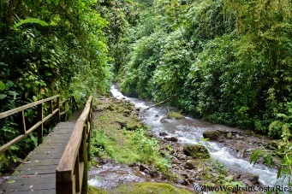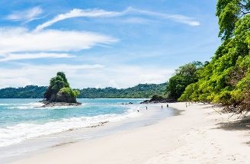Manuel Antonio National Park

**There is/are ….**

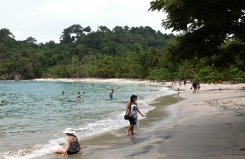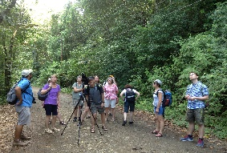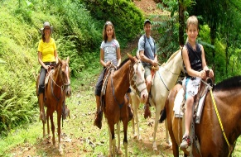

**You can…**

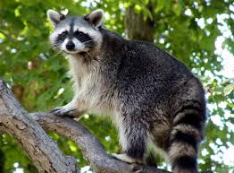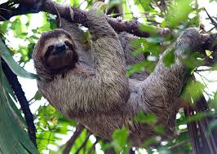**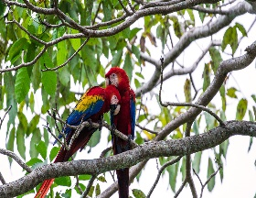You can see…**

**……………………………………………………………………………………………………………………………………………………………………**

1. Now, ask your friend about Arenal Volcano National Park. Illustrate his/her answers.

|  |  |
| --- | --- |
| **What is Arenal Volcano National Park like?** |  |
| **What can you do at Arenal Volcano National Park?** |  |
| **What can you see at Arenal Volcano National Park¨?** |  |

**Info-gap Activity**

**Student B:**

1. 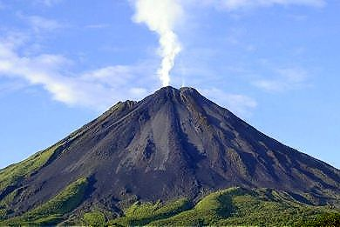Answer your friend’s questions about Arenal Volcano National Park

**There is/are ….**

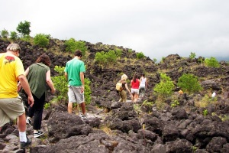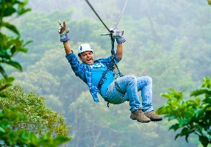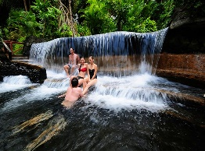

**You can…**

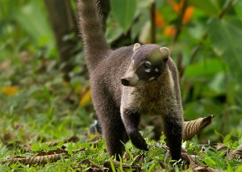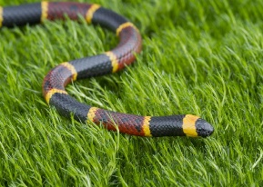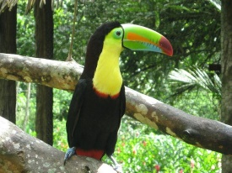**You can see…**

**…………………………………………………………………………………………………………………………………………………………………**

1. Now, ask your friend about Manuel Antonio National Park. Illustrate his/her answers.

|  |  |
| --- | --- |
| **What is Manuel Antonio National Park like?** |  |
| **What can you do at Manuel Antonio National Park?** |  |
| **What can you see at Manuel Antonio National Park¨?** |  |

|  |  |  |  |
| --- | --- | --- | --- |
| **I have**  Resultado de imagen de wildlife costa rica animals | Resultado de imagen de wildlife costa rica animals**I have** | **I have**  Resultado de imagen de wildlife costa rica animals | Resultado de imagen de wildlife costa rica animals**I have** |
| **Who has**  Resultado de imagen de wildlife costa rica animals | **Who has**  Resultado de imagen de wildlife costa rica animals | Resultado de imagen de wildlife costa rica animals**Who has** | **Who has**  Resultado de imagen de wildlife costa rica animals |
| **I have**  Resultado de imagen de wildlife costa rica animals | **I have**  Resultado de imagen de wildlife costa rica animals | Resultado de imagen de wildlife costa rica animals**I have** | Resultado de imagen de wildlife costa rica animals**I have** |
| **Who has**  Resultado de imagen de wildlife costa rica animals | **Who has**  Resultado de imagen de wildlife costa rica animals | Resultado de imagen de wildlife costa rica animals**Who has** | Resultado de imagen de costa rica wildlife raccon**Who has** |

|  |  |  |  |
| --- | --- | --- | --- |
| **I have**  Resultado de imagen de costa rica wildlife raccon | Resultado de imagen de wildlife costa rica animals**I have** | **I have**  Resultado de imagen de costa rica wildlife | Resultado de imagen de costa rica wildlife crocodiles**I have** |
| Resultado de imagen de wildlife costa rica animals**Who has** | Resultado de imagen de costa rica wildlife**Who has** | **Who has**  Resultado de imagen de costa rica wildlife crocodiles | **Who has**  Resultado de imagen de costa rica wildlife ocelots |
| **I have**  Resultado de imagen de costa rica wildlife ocelots | **I have**  Resultado de imagen de costa rica wildlife parrot | Resultado de imagen de costa rica wildlife spider**I have** | **I have**  Resultado de imagen de costa rica wildlife turtle |
| **Who has**  Resultado de imagen de costa rica wildlife parrot | **Who has**  Resultado de imagen de costa rica wildlife spider | **Who has**  Resultado de imagen de costa rica wildlife turtle | **Who has**  Resultado de imagen de wildlife costa rica animals |

**Battleship Task Assessment: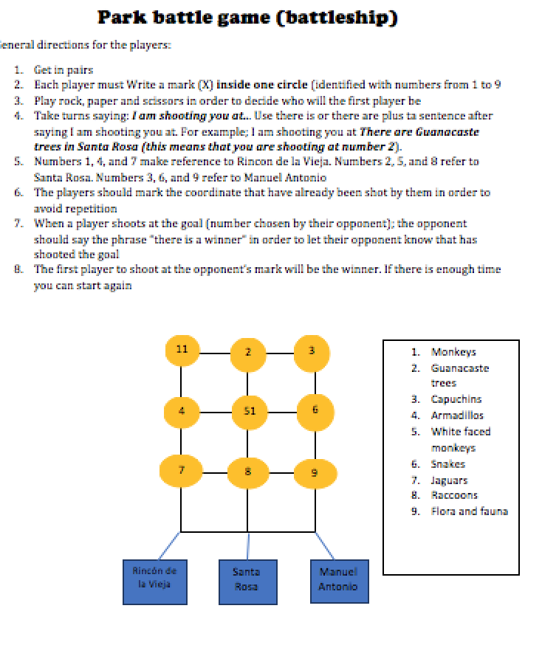**

**Animal Footprints with Names: Animal Footprints without names:**

**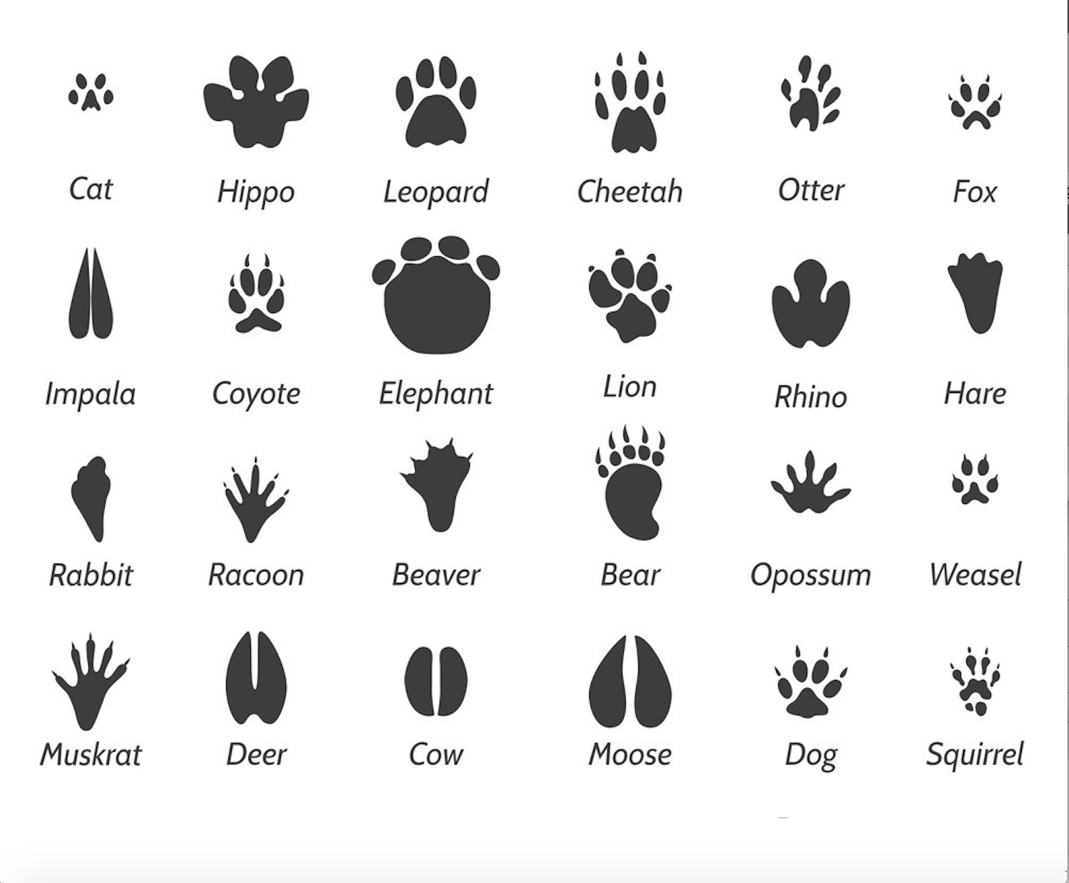 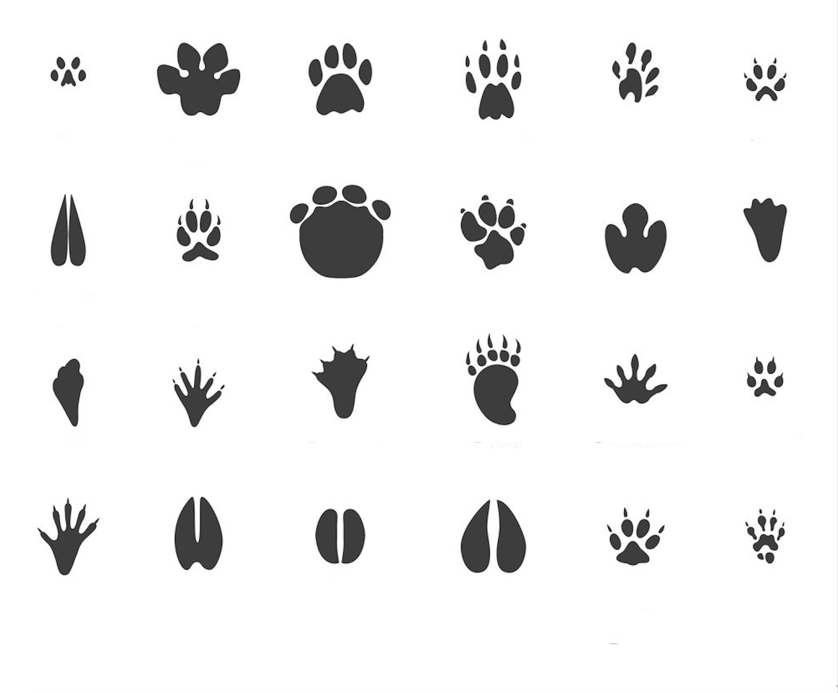**

**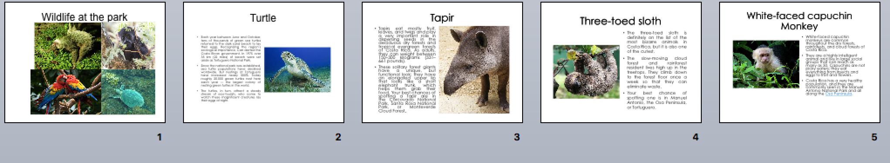Wildlife at Park Pictures:**

|  |  |  |  |  |  |  |  |  |  |  |  |  |  |
| --- | --- | --- | --- | --- | --- | --- | --- | --- | --- | --- | --- | --- | --- |
| **Term: II** | | | **Level: Fourth** | | | | **Unit: 2** | | | | **Week:3** | | |
|  | **Domain: Socio-Transactional** | | | | | **Scenario: Natural Treasures** | | | | **Theme:** A Trip to a National Park | | | |
| **Enduring Understanding**: National parks provide homes and food to animals and jobs, education and entertainment for people. | | | | | | | | | | | | | |
| **Essential Question:** Why do national parks matter to us? | | | | | | | | | | | | | |
| |  | | --- | | **Dimensions** | | **1.** **Ways of thinking ( X )** | | **2. Ways of living in the world ( X )** | | **3. Ways of relating with others ( X )** | | **4. Tools for integrating with the world ( X )** | | | | | | | | | | | | | | |
| **Learn to Know** | | | | **Learn to Do** | | | | **Learn to Be and Live in Community** | | | | | |
| **Grammar & Sentence Frames**  Wh- questions in past tense   * Which National Park did you visit last weekend? * What did you do at Tortugüero? * What did you see?   Yes/No questions in simple past   * Did you swim there? Did you see any animals? * Did you like it?   **Vocabulary**  3. A Trip to a National Park  Activities in past tense:   * Saw, Went * Ate, swam * Took, walked * Watched, visited * Listened, learned   **Phonology**  **Phonemic Awareness**  Identifying short vowel sounds **(-at, -in, -ot) in orally stated single-syllable words. (e.g., hen, hat, mad, hot.)** | | | | **Function**   * Describing past experiences   **Discourse Markers**  Linkers: Sequential - past tense  First, then, after that, finally | | | | **Psycho-social**   * Working cooperatively with others.   **Sociocultural**   * Following conventions for turn taking   **Idioms/phrases**   * “When it rains, it pours.” (When something good or bad occurs, it usually occurs more than once.) | | | | | |
| **Assessment Strategies & indicators of learning**  (Diagnostic, formative, summative) | | **Goals** | | **Pedagogical Mediation/ Didactic Sequence** | | | | | | | | | **Time** |
| Learner…  **L.3.** Recognizes the most important points in a straightforward talk or presentation.  **Indicator of learning**  Recognizes the most important points about a national park in a straightforward presentation  **R.2**. Comprehends reading by analyzing it and enjoying texts.  **Indicator of learning:**  Follows organization of a written passage.  Identifies specific information about national parks from written text.  **SI.1**. Asks straightforward questions in familiar situations and understands the responses in an info-gap activity.    I**ndicators of learning**   * Asks straightforward questions appropriately about Costa Rica’s national Parks in an info-gap activity * Recognizes what has been said about Costa Rica’s national parks in an info-gap activity.   **W.1**. Engages in the writing process: pre-drafting, drafting when writing sentences.  **Indicators of learning:**  Pre-drafts his/her piece of writing  Revises is/her piece of writing  Edits his/her piece of writing.  Publishes his/her piece of writing  Organizes a story in a logical sequence  **R.PA.2**. Reads words decoding English graphemes and phonemes using knowledge of phonemic awareness.  **Indicator of learning:**  Substitutes initial sounds to make new words  Reads words in the **-ot** family.  Reads words in the **-at** family.  Reads words in the **-in** family. | | Learner can  **L.3**. Recognize the most important points in a straightforward talk or presentation.  **R.2**. comprehend readings and enjoying texts.  **SI.1**. ask straightforward questions in familiar situations and understand the responses.  **W.1**. engage in the writing process: pre-drafting, drafting.  **R.PA.2**. decode English graphemes and phonemes using knowledge of phonemic awareness. | | **Pre-teaching**  **Routine:** Checking attendance, checking in with Ls, T posts the, and class agenda, etc.  **Warm up**  In a circle,students are going to play the “hot jar”. In a jar there are pictures of wildlife animals. Learners pass the hot jar around while the teacher claps. When the teacher stops, they have to pick up a picture from the jar and use “There/are… in, to talk about the animal(s).  **Activation of prior knowledge**  Students are shown this video [**https://www.youtube.com/watch?v=WXX9u8GrOG4**](https://www.youtube.com/watch?v=WXX9u8GrOG4)Then, Teacher asks wh-questions about what they watched in the video.  **E.g.**  What places did you see?  What animals did you see?  What activities did people do?  **Modelling**  Teacher introduces sentence frames related past experiences in National Parks by using some pictures.  **Ex:** I took a bus. / I swam in the river. / I watched a butterfly. / I ran a lot. / I ate ceviche. / I hiked the trails. / I visited the forest. / I observed the wildlife animals. / I did some adventure activities. / I heard the sounds of nature. / I walked the dog. / I drank water/ I took a boat tour. /  **Clarifying**  The learners observe as the teacher places the pictures from the modeling section all around the classroom. Then, the class is divided into two teams. A student from each team races to look for the picture representing what the teacher says:  **E.g**. *At Tortuguero, I took a boat tour.*  *At Arenal Volcano National Park, I hiked the trails*  **Pre-task**  Learners review the target vocabulary (walked, swam, hiked, took, ate, saw, etc.) by playing Tic-tac-toe.   1. The game is played on a grid that's 3 squares by 3 squares. 2. Half of the class is X; the other half is O. Players take turns to choose one of the target words and create a sentence. If the sentence is well-structure, the group can write and X or O in the corresponding space. The first team to get 3 of her marks in a row (up, down, across, or diagonally) is the winner. When all 9 squares are full, the game is over.   **Task-Rehearsal**  Learners listen to the teacher as she gives an oral presentation about a trip one of his/her friends (Tina) took to Tapandi National Park (See annexes). The class is divided into pairs. As pairs listen to the teacher, they look for the answer to the following questions:   * What is Tapandi National Park like? * What did Tina see at Tapandi? * What did she do at Tapandi?   Two pairs get together and share their answers. Then, the answers are shared with the whole class.  **Note:** The teacher repeats the oral presentation twice (or three times if necessary.)  **Task- Completion**  Learners, individually, listen to the audio ‘**My visit to Rincón de la Vieja National Park**” and complete the multiple-choice exercise.  **Instructions:**  Listen to Thomas giving an oral presentation about his visit Rincón de la Vieja National Park, and then choose the answer that best completes each statement.   1. **What is Rincón de la Vieja National Park like?** 2. There are sandy beaches and a jungle. 3. There is a volcano and a jungle 4. There are rivers and a volcano. 5. **What activities did he do at Rincón de la Vieja National Park?** 6. Hiking and swimming under the waterfalls, 7. Zip lining and swimming 8. hot springs and hiking 9. **What wildlife animals did he see at Rincón de la Vieja National Park?** 10. Slots, snakes and spiders 11. Lizards, monkeys, and turtles 12. Monkeys, sloths, and tapirs   **Task-Assessment**  The class is divided in pairs. Each student gets one of the collages below. They ask each other questions about the collage.   * What places did he/she see? * What animals did he/she see? * What activities did he/she do?   Techer monitors learners’ performance.   |  |  | | --- | --- | | **Sandy’s trip to Costa Rica** | **Eric’s trip to Costa Rica** | | Resultado de imagen de visit  costa rica collage |  |   **Pre-task**  The teacher asks learner to think about their last vacation. Then, one by one, he/she presents the following questions and the answers.   * + - 1. **Where did you go?** I went to ….       2. **When did you go?** I went to…. in ……       3. **Who did you go with?** I went with my…       4. **What did you see?** I saw ….       5. **What activities did you do?** I ….   Using his/her own information, the teacher provides an answer to each question.    **Task-rehearsal**  Teacher reads the following text along with the students.  **A breath of fresh air**  Last weekend I **took** a breath of fresh air. My family and I **went** to Guanacaste to visit Ostional Wildlife Reserve. I had never **visited** this place before. First, we **made** a long trip to Guanacaste while we **saw** wonderful landscapes as beaches, forests and waterfalls. Then, we **arrived** at an amazing beach on the road and we **walked** on the sand…… ( See annexes)  Teacher asks students to pretend they are the person who went to Ostional. Then, the teacher reads the text along with the students and act out the different activities. After that, the teacher distributes colored popsicles. In a circle, students play the “electric popsicles” switching spaces according to the color mentioned. They are going to discuss the following questions when they switch places:   * + - 1. **Where did you go?** I went to ….       2. **When did you go?** I went to…. in ……       3. **Who did you go with?** I went with my…       4. **What did you see?** I saw ….       5. **What activities did you do?** I ….   **Task completion**  Leaners observe the teacher as he/she writes ‘**Oscar’s trip to** **Ostional Wildlife Refuge**’ on the board. Teacher gives a set of pictures and a text cut into pieces ( text -picture). Learner read the text and match the pictures to the corresponding text.      Students do peer assessment to check if the text has adequate sequence and matches with the corresponding picture.  **Task Assessment**  Learners, in pairs, work on a matching exercise (question-answer)   |  |  |  |  | | --- | --- | --- | --- | | **A** | | **B** | | | Where did Oscar go?  When did he go?  Who did he go with?  What did he see?  What activities did he do? | ( )  ( )  ( )  ( )  ( ) | a.  b.  c.  d.  e. | He went to Ostional with his family.  He saw landscapes, beaches, forests, and waterfalls  He went to Ostional Wildlife Refugee  He ate ceviche, swam in the river, and observe turtles.  He went to Ostional last weekend. |   Learners check their answers as a group.  **Pre-task**  Teacher presents the vocabulary and Wh-Qs by using pictures of the different places visited.  <https://drive.google.com/drive/folders/1Lf_x67QTCCX5Q8Zv5zP87clUILKGmcG9>  •Which National Park did you visit?  •Where did you go?  •What did you do?  •What did you see?  **Task-rehearsal**  Teacher gives Learners pictures from different places (use pictures from pre-task), so they answer simple questions using the information written in the images.  •Which National Park did you visit?  •Where did you go?  •What did you do?  •What did you see?  **Task completion**  Learners use the following pictures to work in pairs in an info-gap activity where they have to make past tense Wh-Qs to guess the place that the other partner has and the other participant answers without saying the name of the place he/she describes.    **Task assessment**  <https://drive.google.com/drive/folders/1Lf_x67QTCCX5Q8Zv5zP87clUILKGmcG9>(use pics from pre-task)  Teacher places the pictures upside down. Learners play hot potato. Every time a learner gets the ball, he/she will choose a picture and describe it in order to the other Learners figure out which place is being described. (Use Wh-Qs and Sentences frames in past tense)  **Pre-task**  Teacher shows a Short Story by using a digital Retell-Rope based on a trip made in Lesson 2.  <https://drive.google.com/drive/folders/1xoIcRX8W26Z7SiRMUztEsFnkfRCLNdTG>  **Task-rehearsal**  Teacher retells the story to learners and makes some Wh-questions to clarify the structure of the story and its details.  e.g. What did they see/eat? Where did they go?...etc    <https://drive.google.com/drive/folders/1xoIcRX8W26Z7SiRMUztEsFnkfRCLNdTG>  **Task completion**  Learners do a pre-drafting in a worksheet by writing the information required.    [**https://drive.google.com/drive/folders/1xoIcRX8W26Z7SiRMUztEsFnkfRCLNdTG**](https://drive.google.com/drive/folders/1xoIcRX8W26Z7SiRMUztEsFnkfRCLNdTG)  **Task assessment**  Learners create their own story by using linkers and the past tense words provided in the pre-task.    <https://drive.google.com/drive/folders/1xoIcRX8W26Z7SiRMUztEsFnkfRCLNdTG>    **Post-Task**  Teacher asks for students to volunteer and share their short story.   |  |  |  |  | | --- | --- | --- | --- | | **Self-Assessment** | **Yes** | **On my way!** | **Help!** | | I can organize a story in a logical sequence |  |  |  | | I can refer to past experiences |  |  |  |   **Pre-task**  Students listen to a video and sing the phonics song   * **ot family** [**https://www.youtube.com/watch?v=aKfEWJPgd0E**](https://www.youtube.com/watch?v=aKfEWJPgd0E) [**https://www.youtube.com/watch?v=E2ZghKzfJE0**](https://www.youtube.com/watch?v=E2ZghKzfJE0) * **at family** [**https://www.youtube.com/watch?v=DkUunCjP3Hs**](https://www.youtube.com/watch?v=DkUunCjP3Hs) * **in family** [**https://www.youtube.com/watch?v=P6UFtbsLXPY**](https://www.youtube.com/watch?v=P6UFtbsLXPY)   **Task-rehearsal**  Teacher will tell the students a set of words and the students will say the word family.  Examples:  1. Teacher says cat, bat, mat… rhyme is? Students will then say “at”  2. Teacher says cot, hot, pot… rhyme is? Students will say “ot”  3. Teacher say bin, tin, win… rhyme is? Students will say “in”  Teacher can continue with a few more examples to check for understanding.  **Task completion**  Students do phoneme substitution by using the following videos.  **-** [**https://www.youtube.com/watch?v=wo3KP0TFw4s**](https://www.youtube.com/watch?v=wo3KP0TFw4s) **ot**  **-** [**https://www.youtube.com/watch?v=HjJ4BTm8fdE**](https://www.youtube.com/watch?v=HjJ4BTm8fdE) **at**  **-**[**https://www.youtube.com/watch?v=aZmL3feY-zY**](https://www.youtube.com/watch?v=aZmL3feY-zY) **in**  **Task assessment** | | | | | | | | |  |
| **Integrated Mini-Project** | | | | | | | | | | | | **Time** | |
| * **Planning:** The class is divided into groups of three. Learners are told they are tourist guide going to a tourist fair. They have to advertise the beauties found in Costa Rica National Parks. Each group decides on a National Park they would like to create a poster about and the information they would like to include. * **Creating:** Learners design their poster. * **Rehearsing:** Learners rehearse their presentation * **Participating:** Learners present their poster orally: self and peer assessment | | | | | | | | | | | | Learners present their poster orally in week 5 or 6 | |
| **Reflective Teaching** | | | | | | | | | | | | | |
| What worked well | | | | | What didn’t work well | | | | How to improve | | | | |
| **Enduring Understanding Reflection** | | | | | | | | | | | | | |
|  | | | | | | | | | | | | | |

|  |  |  |  |
| --- | --- | --- | --- |
| **Learner Self-Assessment** | | | |
| ***I can…*** | ***Yes*** | ***Sort of*** | ***No. Help!*** |
| Recognize the most important points in a straightforward presentation about a national park. |  |  |  |
| Follow the organization of a written passage. |  |  |  |
| Identify specific information from written text about national parks |  |  |  |
| Ask straightforward questions appropriately about Costa Rica’s national Parks in an info-gap activity |  |  |  |
| Recognize what has been said about Costa Rica’s national parks in an info-gap activity. |  |  |  |
| Organize a story in a logical sequence |  |  |  |
| Substitute initial sounds to make new words |  |  |  |
| Read words in the **-ot** family. |  |  |  |
| Read words in the **-at** family. |  |  |  |
| Read words in the **-in** family. |  |  |  |

**Listening: Task Rehearsal**

**Script**

**Tina’s trip to Tapanti National Park**

Hi, my name is Tina. Last December I went to Costa Rica, and I visited Tapanti National Park. The park offers visitors many activities to do. I hiked the trails, swam in the river and enjoyed the picnic areas. Also, wildlife is awesome. I saw many quetzals and other animals such tapirs, raccoons, snakes, white-tail deer, and white-faced monkeys. Tapanti National Park is an excellent choice for a day trip.

**Listening Exercise (Task-Completion)**

**Script**

Last February I went to Costa Rica and I visitedRincon de la Vieja Volcano National Park. This park is situated in the popular [Guanacaste region](https://www.govisitcostarica.com/region/guanacaste/guanacaste.asp) of Costa Rica. This park is characterized by a volcano and jungle. During my trip Rincon de la Vieja National Park, I went hiking to the trails and swam under beautiful waterfalls. Also, wildlife is amazing. I saw monkeys, sloths, and tapirs. There are hotels nearby, but camping is also permitted within this park for those wishing to spend some more time in the great outdoors. I loved my trip to this place.

|  |
| --- |
| **Listening Exercise**  **Instructions:** Listen to Thomas giving an oral presentation about his visit Rincón de la Vieja National Park, and then choose the answer that best completes each statement.  **What is Rincón de la Vieja National Park like?**  There are sandy beaches and a jungle.   * 1. There is a volcano and a jungle   2. There are rivers and a volcano.   **What activities did he do at Rincón de la Vieja National Park?**  Hiking and swimming under the waterfalls,   * + - * 1. Zip lining and swimming         2. hot springs and hiking  1. **What wildlife animals did he see at Rincón de la Vieja National Park?**    1. Slots, snakes and spiders    2. Lizards, monkeys, and turtles    3. Monkeys, sloths, and tapirs |

**A Breath of Fresh Air:**

**A breath of fresh air**

Last weekend I **took** a breath of fresh air. My family and I **went** to Guanacaste to visit Ostional Wildlife Reserve. I had never **visited** this place before. First, we **made** a long trip to Guanacaste while we **saw** wonderful landscapes as beaches, forests and waterfalls. Then, we **arrived** at an amazing beach on the road and we **walked** on the sand. My father **listened** that the turtles were outside. So, we **moved** quickly to the next beach where they nest. After that, we **found** a tour guide near Ostional beach. She **told** us that the turtles travel lots of distance to lay their eggs on the beach that they have been born. I also **learned** that they swim with the sea currents and that they use the stars to locate themselves. Finally, we **ate** ceviche in a local restaurant and we **swam** in the peaceful river.

1. Cut the paragraphs and ask the students to build a whole text. Match them to the pictures.

|  |  |
| --- | --- |
| **Questions**   1. Where did you go? 2. When did you go? 3. Who did you go with? 4. What did you see at the beach? 5. Where did you swim? 6. What did you learn? 7. What did you eat? | **Yes /no**   * Did you swim there? * Did you see turtles? * Did you like it? |

Activities in past tense:

* Saw, Went
* Ate, swam
* Took, walked
* Watched, visited
* Listened, learned
* Did

|  |  |
| --- | --- |
|  |  |
| Last weekend I **took** a breath of fresh air. My family and I **went** to Guanacaste to visit Ostional Wildlife Refuge. I have never **visited** this place before. |  |
| *First*, we **made** a long trip to Guanacaste while we **saw** wonderful landscapes as beaches, forests and waterfalls. |  |
| *Then*, we **arrived** at an amazing beach on the road and we **walked** on the sand. My father **listened** that the turtles were outside. | The geology at ostional is very interesting, this outcrops of phiolitics are aproximately 80 million years old. |
| So, we **moved** quickly to the next beach where they nest. *After tha*t, we **found** a tour guide near Ostional beach. |  |
| She **told** us that the turtles travel lots of distance to lay their eggs on the beach that they have been born. |  |
| I also **learned** that they swim with the sea currents and that they use the stars to locate themselves. |  |
| Finally, we **ate** ceviche in a local restaurant and we **swam** in the peaceful river. |  |

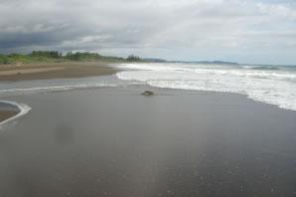

|  |  |  |  |
| --- | --- | --- | --- |
| **A** | | **B** | |
| Where did Oscar go?  When did he go?  Who did he go with?  What did he see?  What activities did he do? | ( )  ( )  ( )  ( )  ( ) | 1.  2.  3.  4.  5. | He went to Ostional with his family.  He saw landscapes, beaches, forests, and waterfalls  He went to Ostional Wildlife Refugee  He ate ceviche, swam in the river, and observe turtles.  He went to Ostional last weekend. |

|  |  |  |  |  |
| --- | --- | --- | --- | --- |
| See | Did | Took | Go | Learn |
| Take | Visit | Saw | Watch | Do |
| Learned | Went | Listen | Eat | Ate |
| Watched | Visited | Walked | Listened | Walk |

**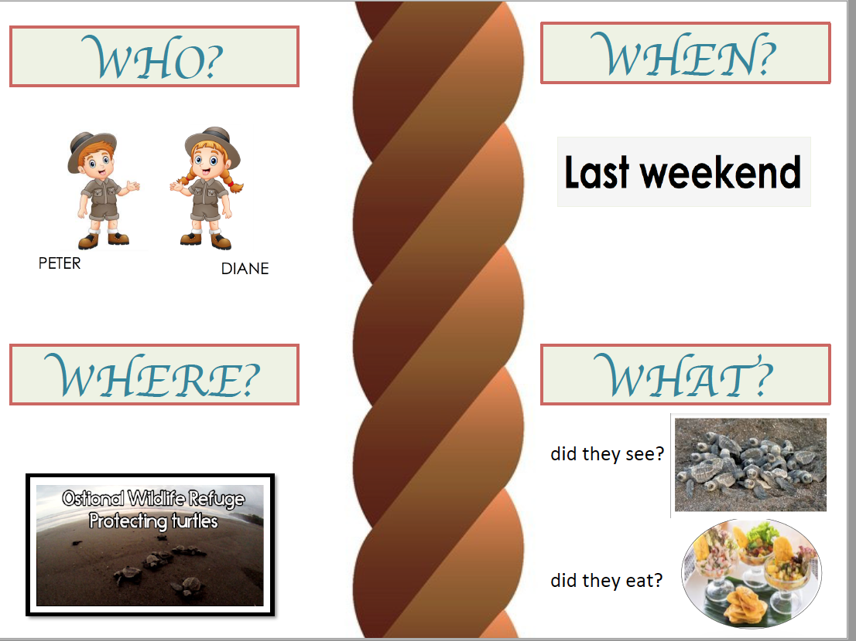**

**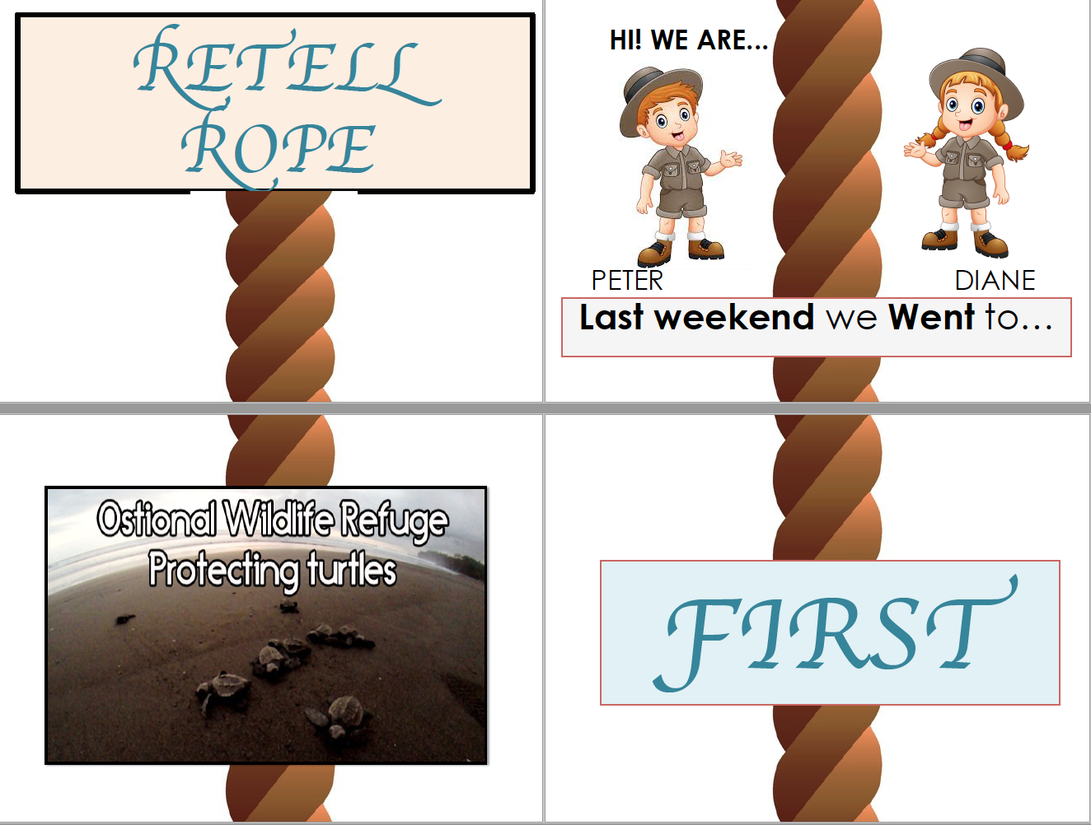**

**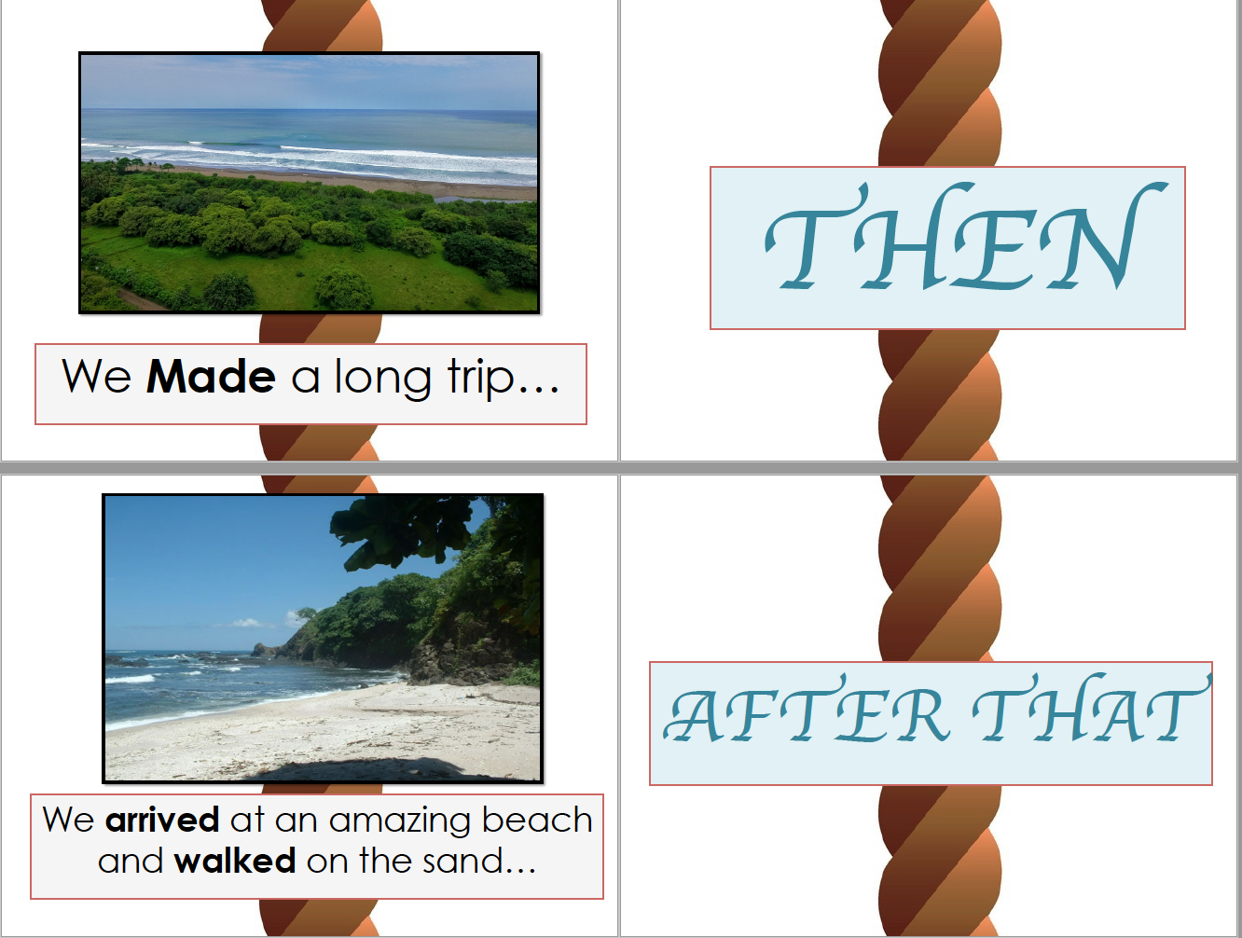**

**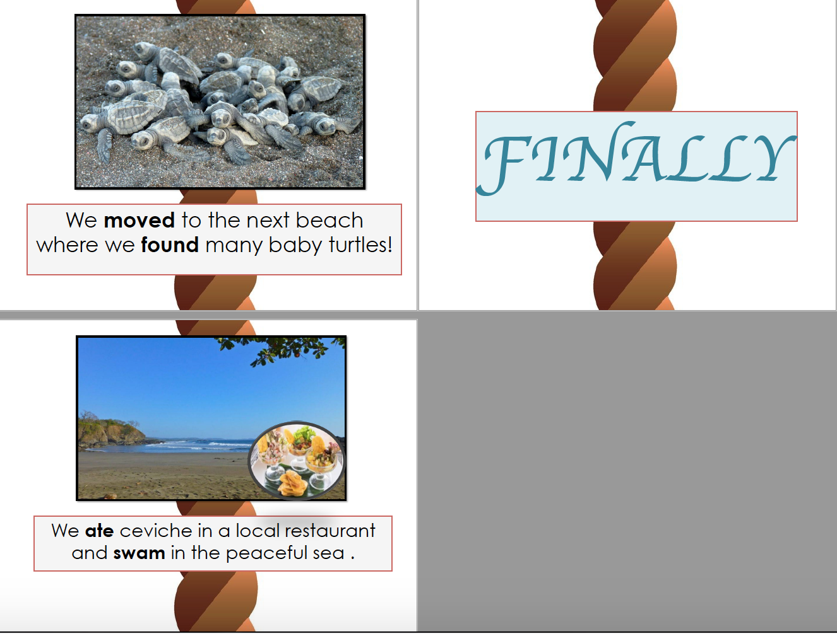**

**Task Assessment \_Writing**

**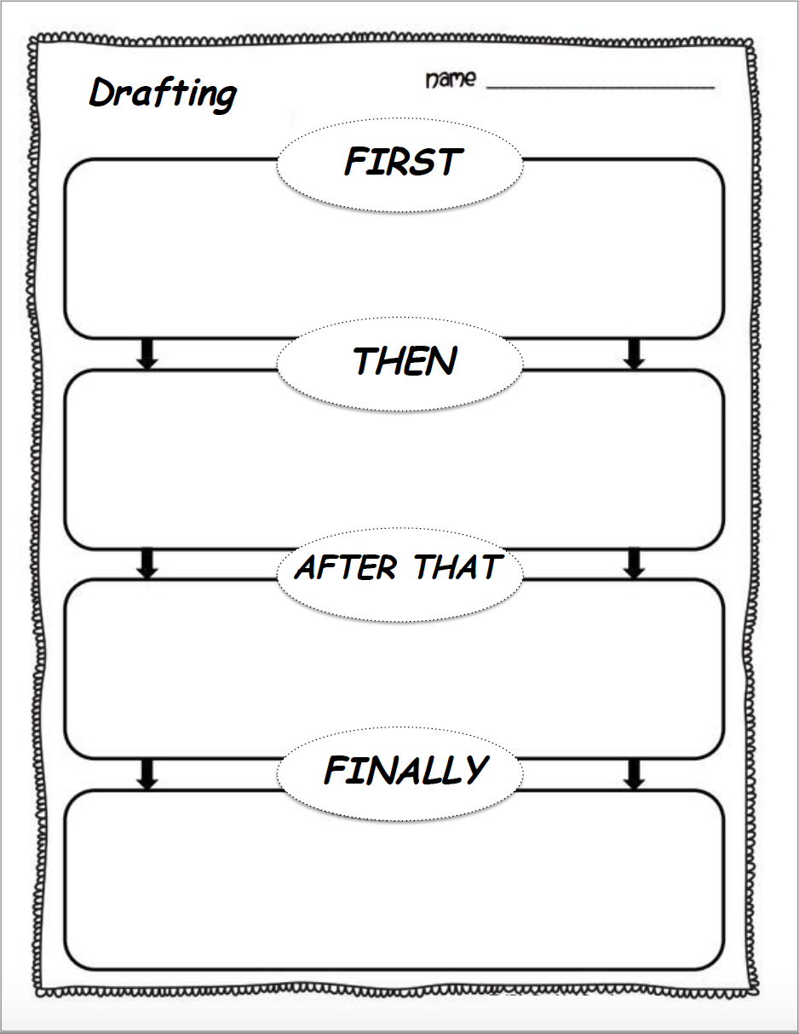**

**Task Completion:**

**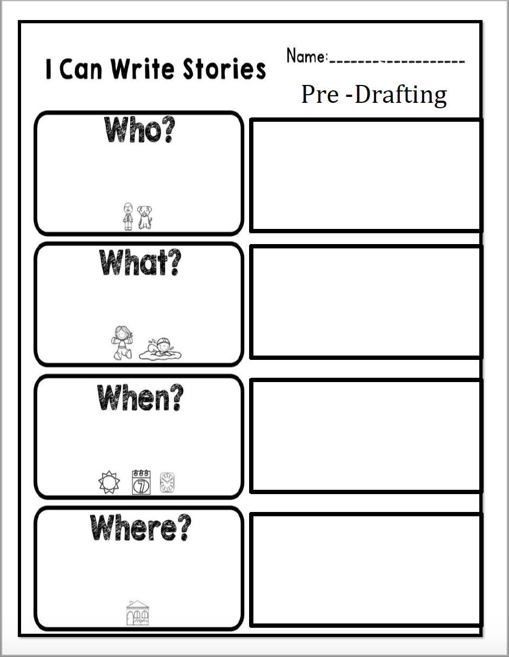**

**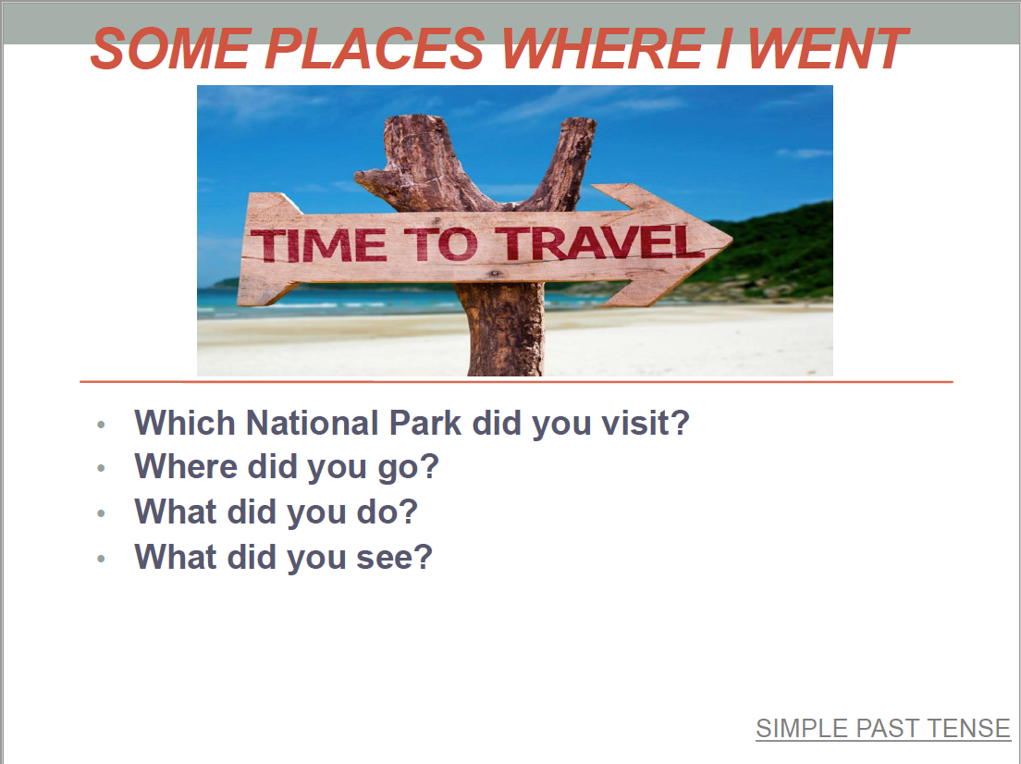**

**Verbs:**

|  |  |  |  |  |
| --- | --- | --- | --- | --- |
| See | Did | Took | Go | Learn |
| Take | Visit | Saw | Watch | Do |
| Learned | Went | Listen | Eat | Ate |
| Watched | Visited | Walked | Listened | Walk |

|  |  |  |  |
| --- | --- | --- | --- |
|  |  |  |  |
|  |  | Resultado de imagen para ver animales picture | C:\Users\user\AppData\Local\Packages\Microsoft.Office.Desktop_8wekyb3d8bbwe\AC\INetCache\Content.MSO\835E62AF.tmp |
|  | C:\Users\user\AppData\Local\Packages\Microsoft.Office.Desktop_8wekyb3d8bbwe\AC\INetCache\Content.MSO\2C047BB3.tmp |  |  |

|  |  |  |  |  |  |  |  |  |  |
| --- | --- | --- | --- | --- | --- | --- | --- | --- | --- |
| **Term: I** | | **Level: Fourth** | | | **Unit: 2** | | | **Week:4** | |
| **Domain: Socio-Transactional** | | | **Scenario: Natural Resources** | | | **Theme:** Protecting our National Parks | | | |
| **Enduring Understanding**: National parks provide homes and food to animals and jobs, education and entertainment for people. | | | | | | | | | |
| **Essential Question:** Why do national parks matter to us? | | | | | | | | | |
| |  | | --- | | **Dimensions** | | **1.** **Ways of thinking ( X )** | | **2. Ways of living in the world ( X )** | | **3. Ways of relating with others ( X )** | | **4. Tools for integrating with the world ( X )** | | | | | | | | | | |
| **Learn to Know** | | | **Learn to Do** | | | **Learn to Be and Live in Community** | | | |
| **Grammar & Sentence Frames**  Modal - should   * People should follow the rules of the park. * Visitors’ shouldn´t throw garbage on the paths. * We shouldn´t feed animals there.   Simple past tense regular and irregular   * I went to Rincón de la Vieja in July. * I hiked to a waterfall. * I swam in the hot spring.   **Vocabulary**  Protecting our National Parks   * Do not litter. * Do not feed the animals. * Do not pollute water. * Do not kill animals or destroy plants and trees. * Protect the wildlife. * Preserve nature.   **Phonology**  **Phonemic Awareness**  Identifying short vowel sounds **(-at, -in, -ot) in orally stated single-syllable words. (e.g., hen, hat, mad, hot.)** | | | **Function**   * Making suggestions   **Discourse Markers**  Linkers: Sequential - past tense  First, then, after that, finally | | | **Psycho-social**   * Working cooperatively with others.   **Sociocultural**   * Using the right choice of interjections (e.g. Oh! Wow! Beautiful!)   **Idioms/phrases**   * “Have the time of my life” ( to enjoy an experience very much) | | | |
| **Assessment Strategies & indicators of learning**  (Diagnostic, formative, summative) | **Goals** | | **Pedagogical Mediation/ Didactic Sequence** | | | | | | **Time** |
| Learner…  **L.3**. Recognizes the most important points in a straightforward talk or presentation.  **Indicator of learning**  Recognizes the most important points in a straightforward oral presentation about ways to protect national parks.  **SI.2**. Exchanges information about everyday matters using simple vocabulary during dialogues and conversations.  **Indicators of learning**  Asks for suggestions on how to protect the environment.  Makes suggestions on how on to protect the environment.  **R.3**. Follows a set of clear-cut instructions.  **Indicator of learning**  Follows a set of clear-cut written instructions.  **W.2**. Uses simple sentences and expressions to describe people and things.  **Indicator of learning**  Uses simple sentences and expressions to refer to ways of protecting national parks.  **R.PA.2**. Reads words decoding English graphemes and phonemes using knowledge of phonemic awareness.  **Indicator of learning:**  Reads words in the **-ot** family.  Reads words in the **-at** family.  Reads words in the **-in** family. | Learner can  **L.3**. Recognize the most important points in a straightforward talk or presentation.  **SI.2.** Exchange information about everyday matters using simple vocabulary during dialogues and conversations.  **R.3**. follow a set of clear-cut instructions, especially if there are pictures or diagrams to illustrate the most important steps.  **W.2**. use simple sentences and expressions to describe such things as their surroundings, their daily activities, and the people around them.  **R.PA.2.** decode English graphemes and phonemes using knowledge of phonemic awareness.  surroundings, their daily activities, and the people around them. | | **Pre-teaching**  **Routine:** Checking attendance, checking in with Ls, T posts the Essential Question on the board, and class agenda, etc  **Warm up**  Students take a trip to an imaginary wild place. Students are asked to close their eyes and listen to the following video: [**https://www.youtube.com/watch?v=PU0rVQqKEEk**](https://www.youtube.com/watch?v=PU0rVQqKEEk).  Then, students open their eyes and the video is played again.  Teacher encourages learners to talk about how human behavior has developed a negative impact on national parks. Students are encouraged to reflect on how we can protect our national parks. They explain that the impact of visitors on the environment can be severe, even though the damage they cause may be entirely unintentional.  A brainstorming could be done on the board.  (For example - Litter - Broken branches - Ring barked trees -Trampled vegetation • Headless flower stalks • Graffiti • Missing or relocated rocks - Removal of timber - Boise - Artificial light - Graffiti on Aboriginal sites -Feeding native animals)  **Activation Prior knowledge**  Learners watch the video:  [**https://www.youtube.com/watch?v=BZvE25UGQxE**](https://www.youtube.com/watch?v=BZvE25UGQxE)  Teacher encourages students to answer the questions:  -How can people preserve different animal species?  -What can people do to take care of animals at the national parks?  (Buy sustainable products, set up preserves/national parks, pass laws, help local people find other sources of income, reduce emissions that lead to climate change)  **Modeling**  Teacher writes ‘**How can we protect our national parks?**’ on the board. Then, he/she draws two columns:   |  |  | | --- | --- | | **C:\Users\Gabriela Castillo\AppData\Local\Microsoft\Windows\INetCache\Content.MSO\8BA32C96.tmpShould** | **C:\Users\Gabriela Castillo\AppData\Local\Microsoft\Windows\INetCache\Content.MSO\DA7BD14.tmpShouldn’t** | |  |  |   Teacher sticks cards with pieces of advice on each column, reads them, and explains meaning by using mimics and drawings.  **Pieces of advice:**  The teacher says: “**You should…”**   * Save energy. Switch off lights you don't need. * Save paper. * Plant trees. * By biodegradable cleaning products * Use reusable bags instead of paper ones. * Recycle, reduce, and reuse different products   **You shouldn’t…**   * Waste water * Litter * Feed the Animals. * Pollute Water. * Kill Animals * Destroy plants and trees.   Teacher reads each piece of advice twice, sticks it in the right column, and invites learners to pronounce each statement after him/her.  Teacher reinforces the target vocabulary by modeling the pronunciation of key phrases. Students participate in choral repetition.  <https://docs.google.com/presentation/d/1MvCR8Cb36XsA1rSUUxpv6TdHGHMpoHUTVvIqQXyGbwY/edit#slide=id.g706b0d871c_0_103>  **Clarifying**  All the cards used in the modeling section are keep hidden. Some volunteers go to the front and paste the cards on the corresponding place. As each learner sticks the card, he/she reads the piece of advice using should or shouldn’t. The rest of the students provide feedback.  Teacher holds the cards up on the air and asks: **“Should we kill animals**?” and the learners answer**: “No, we shouldn’t. “Should we save energy?” Yes, we should.**  **Pre-task**  Teacher shares the goal of the lesson.  Learners review the target language by playing a memory game where they match a piece of advice to pictures.   The learners shuffle the sets of cards separately and spread them out face down on the floor in two sets. Students then take it in turns to turn over one picture card and one piece of advice. If the cards match, the student keeps the cards and has another turn. If the cards don't match, the student turns them back over, keeping them in the same place. The game continues until all the cards have been matched. The student with the most pairs of cards at the end of the game wins.  Next, the teacher uses the card to review them with the class.  **Task-rehearsal**  Teacher distributes the cards with the pieces of advice among the learners. They are told that the teacher was asked to record a video giving an oral presentation on how to protect our national parks. As they listen to the teacher recording, anytime one of the pieces of advice is mentioned, the learner with that card stands up and remains that way until the teacher’s recording finishes.  All the learners standing up go to the front and the rest of the class decides if those pieces of advice were mentioned or not.  **Task-completion**  Learners, individually, work on the following listening exercise:  **Instructions:** Listen to Karla giving a presentation to her class on how to protect national parks. What suggestions does she give? Check the corresponding answers.   |  |  | | --- | --- | | * Switch off lights you don't need. * Don’t waste paper. * Plant trees. * By biodegradable cleaning products * Use reusable bags * Don’t destroy plants and trees. | * Recycle, reduce, and reuse * Don’t waste water * Don’t litter the parks * Don’t feed the Animals. * Don’t pollute water. * Protect Animals |   **Task-assessment**  Learners play **“Chinese Whispers**”. The class is divided into three groups. Each group forms a line, and the first player comes up with a message (a piece of advice to protect national parks) and whispers it to the ear of the second person in the line. The second player repeats the message to the third player, and so on. When the last player is reached, they announce the message they heard to the entire group. The first person then compares the original message with the final version.  **Pre-task**  Teacher shares the goal of the lesson.  Students are shown a collage about actions we can do to take care of protected areas in order to review vocabulary and expressions.  E.g. We should \_\_\_\_\_\_\_\_\_\_\_\_\_\_\_ / We shouldn’t \_\_\_\_\_\_\_\_\_\_\_\_\_\_  Pictures for creating the collage can be found at <https://drive.google.com/open?id=1JrFYU1GJS7qem9u4OiKIXe1mpIEenNYZ>  **Task-rehearsal**  Teacher pastes the handout below on the board. Using the images as stimulus, the teacher asks the group as he/she points to one of the pictures: *“What should we do to save the Earth?* The learners are encouraged to make suggestions: *“We should plant trees?* Then, the teacher asks: *What shouldn’t we do to save the Earth?* The learners suggest: *We shouldn´t use plastic bags.”* Volunteers go to the front and asks questions to their peers.  Then, the class is divided into pairs. Learners asks each other and use the pictures of the handout to answer.  **Task completion**  The teacher cuts the handout into pieces and divides the class into two groups: A and B. Each student from Group A gets one of the pieces of advice; Group B asks questions about what we should/shouldn’t do to save the Earth. Learners mingle around asking for and giving suggestions on to protect the environment.  After some time, the groups switch roles.    **Task assessment**  Teacher invites the class to go for a tour ride. Teacher arranges the class in order to make it look like the inside of a bus (Parallel lines with students sitting in pairs).  Students watch the video, while the Teacher is driving the bus. Along the video there is a question being displayed; students should shout the word “stop”. Then the teacher reads the question out loud for students to discuss with the person next to them.  Once the students have discussed the question (half a minute or 40 seconds per question) the teacher will ask them to mingle (everybody should sit at a different place). Once they have a new partner, the teacher might ask them to discuss the same question or could play the video again while continuing driving and waiting for the next question in order to start the discussion again.  It is very important to make sure that students sit at a different place before each new question in order to promote socialization and let them share vocabulary with their peers. <https://youtu.be/i7ibzorjeko>  **Pre-task**  Teacher introduces the goal of the lesson. Teacher activates prior knowledge by holding a discussion on why it is important that we look after our natural habitats.  **Prompt question:** What does nature do for us? (provide food, clothing, medicine etc) What can we do to take care of it?    **Task-rehearsal**  Students are shown pictures about problems that can be found in different national parks. Students take a tour around the classroom to read the information on the pictures. Each picture describes problems at national parks.  <https://drive.google.com/open?id=1j7ot1JLHOB8IGmx7AXM9wYny4-aov82p>  Students brainstorm environmental problems found at national parks.  **Task completion**  Students are introduced to the rules for a game of True and False Park Rules. Teacher spreads sheets of newspaper with a big ‘T’ (true) or a big ‘F’ (false) on the floor (12 of each). Students walk slowly around the room. Learners read one of the true or false questions. Students must step on a piece of paper with the correct answer – up to two students per piece of paper. Only those on the correct piece of paper stay in the game. Two sheets from each category (T and F) are removed from the floor each round. The next question is read and the process repeats itself until there is only one person left.  The list of rules can be found at <https://drive.google.com/open?id=18eCV8zB9t99W9I0QOcWxs3Df7fRLpuK_>  **Task assessment**  Students play a game called: four corners.  ***Instructions:*** Teacher numbers the four corners in the room. She / he would randomly choose one student to stand in the middle of the classroom and be “It.” This student must close his/her eyes (or tie up his/her eyes) and count down from ten loudly. The rest of the students should walk to a corner of the classroom (same amount of students per corner). The person in the middle then chooses a number from 1-4, and the students who are in that specific corner of the room must think of a national park rule as a group and say it aloud.  **Pre-task**  Teacher shares the goal of the lesson.  Teacher provides two big signs to paste on the wall opposite sides of the class, one says: Visitors should and the other one says: Visitors Should not. Teacher calls some statements about people’s behaviors at national parks? Learners move from one side to another to choose one of the signs according to what they hear.   * Visitors throw garbage on the paths. * People follow the rules of the park. * We feed animals there. * We litter or contaminate. * Visitors stay on the paths. * We keep up the restrooms clean * We save wildlife. * I went to Rincón de la Vieja and left garbage on the trails. * I hiked to a waterfall and saw people feeding animals. * I swam in the hot spring, but there were a lot of toxic substances. * We walked around Jaco’s Beach and watched people collecting plastic bottles.   **Task-rehearsal**  For this activity everybody sits on the floor in a circle and play **Hot potato.** This game involves learners s gathering in a circle and tossing a small object such as a beanbag or even a real potato to each other while music plays. The player who is holding the object when the music stops must mention something tourist should or shouldn’t do when visiting a national park.  **Task completion**  Learners create a collage in groups of four. They should use all of the sentence frames to write short sentences describing the pictures. This topic would be related to the do’s and don'ts when visiting a national park. Use sentence frame: should- shouldn't. …  <https://drive.google.com/open?id=1JrFYU1GJS7qem9u4OiKIXe1mpIEenNYZ>  **Task assessment**  Using the collage, learners will present an oral presentation to put into practice their background knowledge. Students should read the sentences that they wrote for each picture in their collage.  **Pre-task**  Teacher introduces the goal of the lesson.  Students review the sounds from last week- short vowel sounds (-at, -in, -ot)  Teacher uses flashcards to reinforce each sound and consonant combination      **Task-rehearsal**  Teacher draws a big hopscotch on the floor and places on each spot the (-at, -in, -ot) sounds randomly. For the game, the student will roll the dice, take the allotted number of hops, say a word, and pronounce a word with the sound that they land on to move ahead. Students take turns playing.  **Task completion**  Learners, individually, read words for the **-ot,-at**, and **-in** family. Teacher monitors learners’ performance closely.   |  |  |  | | --- | --- | --- | |  |  |  |   **Task assessment**  Learners identify given words: Teacher uses three different boxes with the three sounds labeled. Learners pick a word from a pile with all mixed words, read the word and place it in the corresponding sound box.. | | | | | | 10 min  10 min |
| **Integrated Mini-Project** | | | | | | | | | **Time** |
| * **Planning:** The class is divided into groups of three. Learners are told they are tourist guide going to a tourist fair. They must advertise the beauties found in Costa Rica National Parks. Each group decides on a National Park they would like to create a poster about and the information they would like to include. * **Creating:** Learners design their poster. * **Rehearsing:** Learners rehearse their presentation * **Participating:** Learners present their poster orally: self and peer assessment | | | | | | | | | Learners present their poster orally in week 5 or 6 |
| **Reflective Teaching** | | | | | | | | | |
| What worked well | | | | What didn’t work well | | | How to improve | | |
| **Enduring Understanding Reflection** | | | | | | | | | |
|  | | | | | | | | | |

|  |  |  |  |
| --- | --- | --- | --- |
| **Learner Self-Assessment** | | | |
| ***I can…*** | ***Yes*** | ***Sort of*** | ***No. Help!*** |
| Recognize the most important points in a straightforward oral presentation about ways to protect national parks. |  |  |  |
| Ask for suggestions on how to protect the environment. |  |  |  |
| Make suggestions on how on to protect the environment. |  |  |  |
| Follow a set of clear-cut written instructions. |  |  |  |
| Usesimple sentences and expressions to refer to ways of protecting national parks. |  |  |  |
| Read words in the **-ot** family. |  |  |  |
| Read words in the **-at** family. |  |  |  |
| Read words in the **-in** family. |  |  |  |

**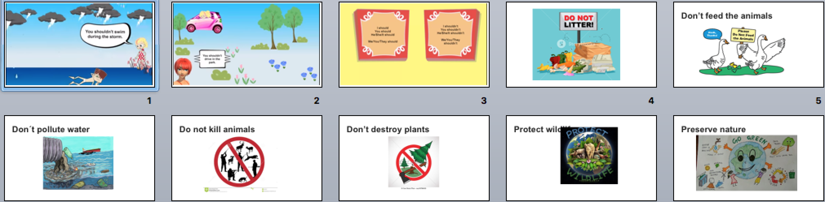Dos and Dont’s Power Point:**

**Script for the listening exercise**

Hello! My name is Karla Larson. I’m 15 years old. Today I’m going to give you some suggestions on how we can protect our national parks. First, don’t use too much water when you wash your hands or take a shower. We shouldn’t waste water. Also, don’t litter the parks. Keep the garbage until you find a trash can. Littering makes our parks dirty. We shouldn’t waste paper, either. We should recycle, reduce, and reuse paper because trees are being cut down to make the paper. We should pant trees and protect the animals.

**Instructions:** Listen to Karla giving a presentation to her class on how to protect national parks. What suggestions does she give? Check the corresponding answers.

|  |  |
| --- | --- |
| * Switch off lights you don't need. * Don’t waste paper. * Plant trees. * By biodegradable cleaning products * Use reusable bags * Don’t destroy plants and trees.   Resultado de imagen de save the environment clipart | * Recycle, reduce, and reuse * Don’t waste water * Don’t litter the parks * Don’t feed the Animals. * Don’t pollute water. * Protect Animals |

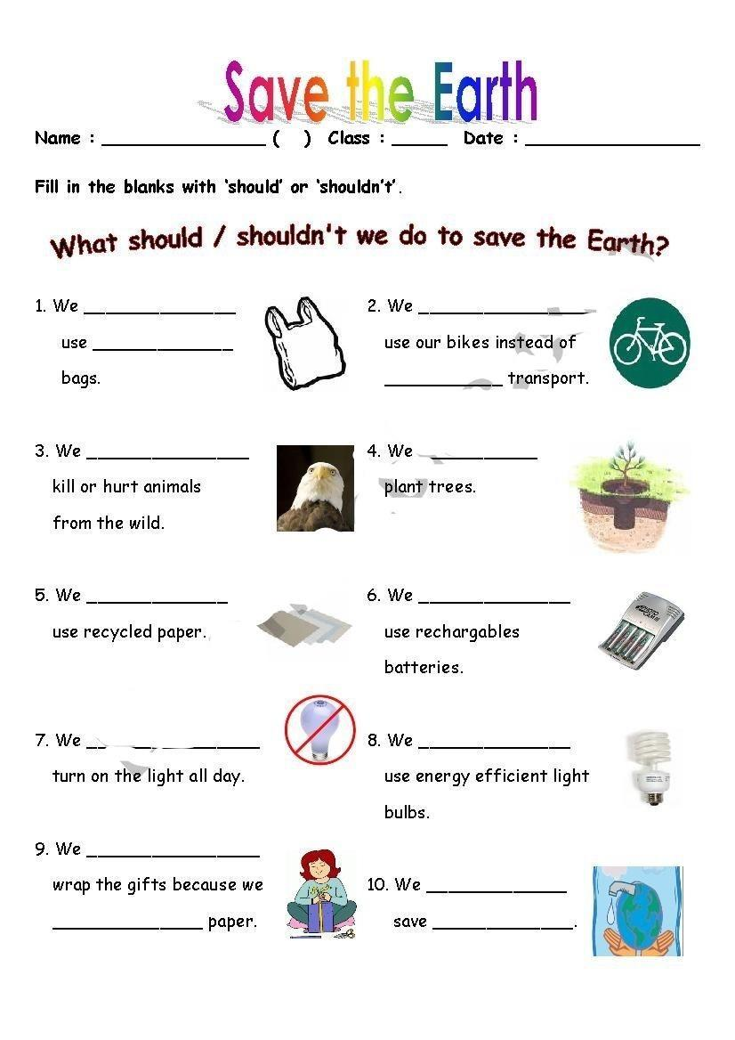

**-at Phonemic Awareness Chart:**

**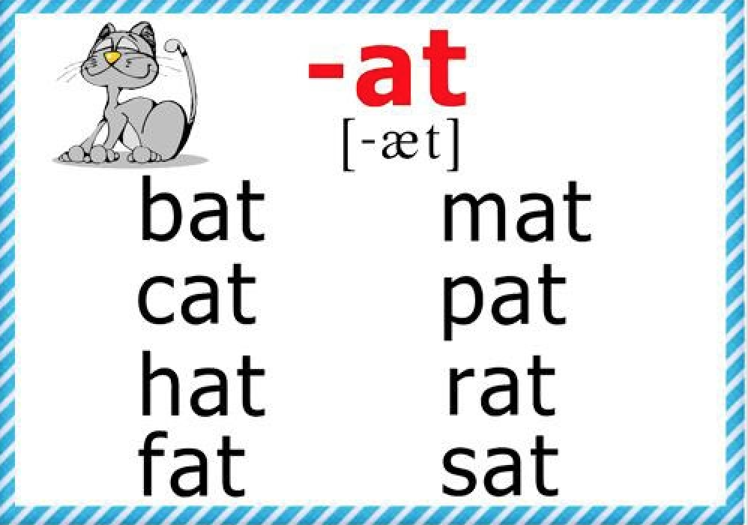**

**-in Phonemic Awareness Chart:**

**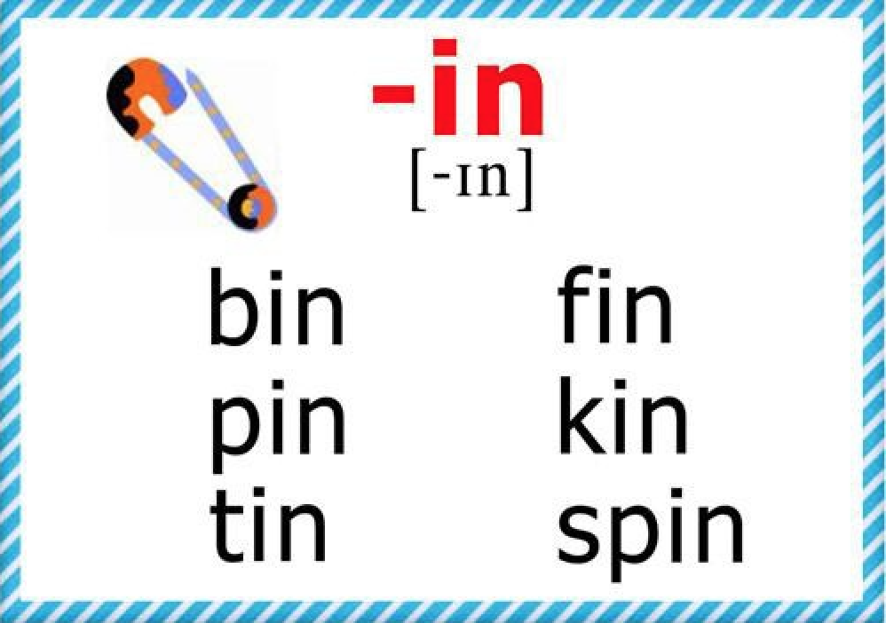**

**-ot Phonemic Awareness Chart:**

**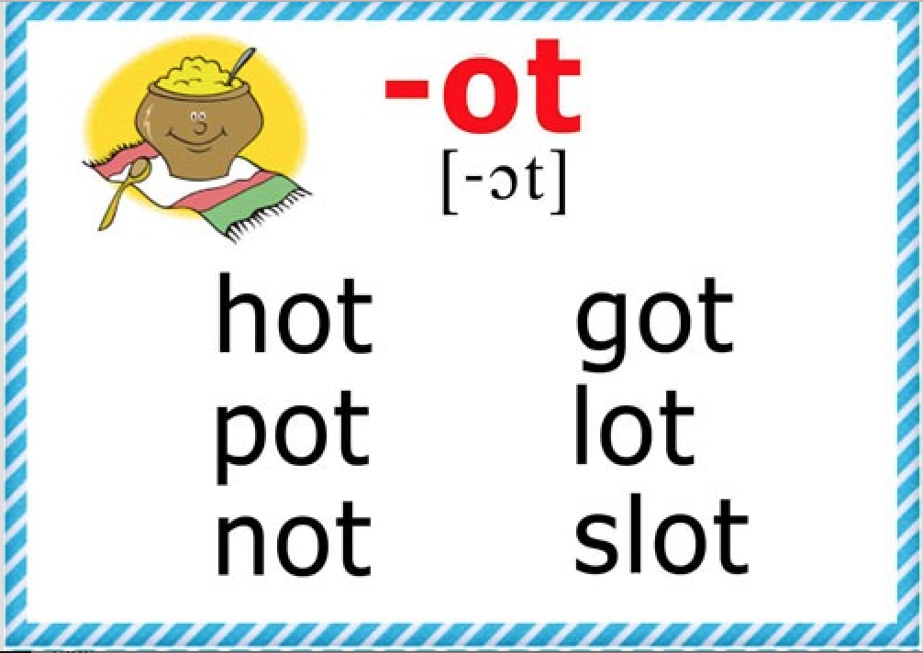**

**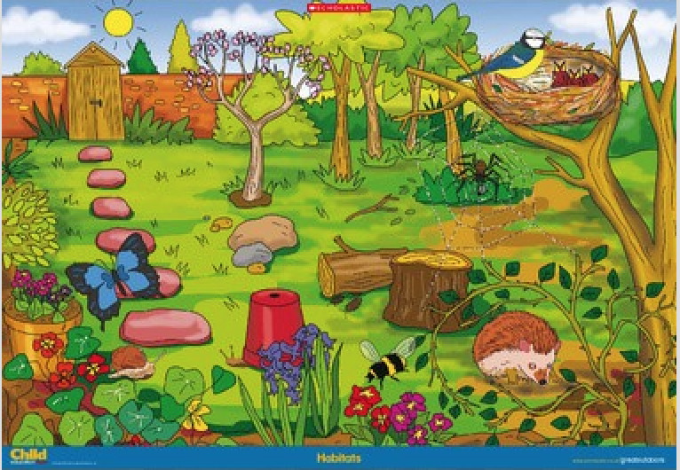**

**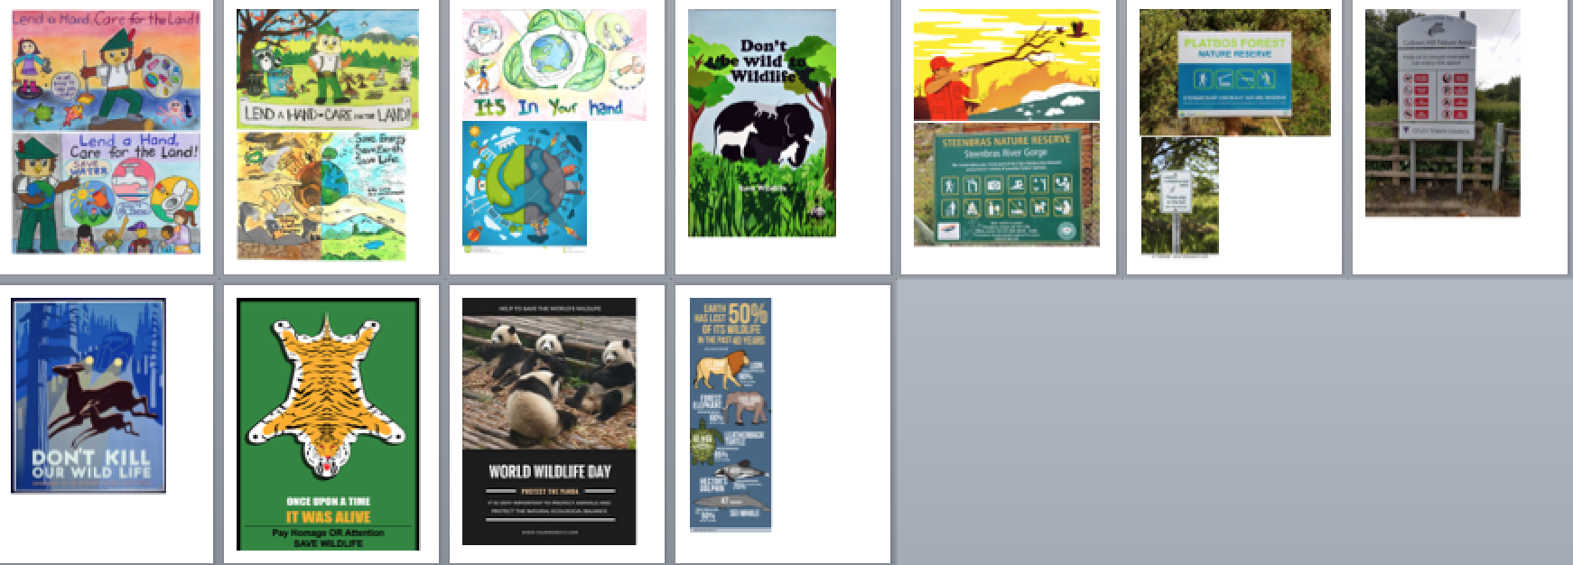**

**True or False Task Completion:**

**List of true and false rules for visiting a national park**

|  |  |
| --- | --- |
| Keep pets at home (T) | Ride your mountain bike on roads but not on walking tracks (T) |
| No kids allowed (F) | Don’t use gas stoves – burn animal homes instead (F) |
| Remove all your rubbish (T) | Don’t feed the wildlife (T) |
| Laughing is not permitted (F) | Only feed animals sausage rolls (F) |
| Do not disturb plants, animals, rocks and soil (T) | Tread lightly – keep to the tracks and trails (T) |
| Picking flowers is allowed on Mondays only (F) | Don’t check the water depth before diving in (F) |
| Motor bikes must stay on roads (T) | Don’t pick flowers (T) Put your tent on top of endangered plants (F) |
| Throw Rubbish in the river (F) | Use toilet facilities not the bush (T) |
| Use your four-wheel drive on walking tracks only (F) | Dump weeds from your garden in the national park (F) |
| Camp in camping areas only (T) | Do not touch or walk on historic sites or Aboriginal sites (T) |

|  |  |
| --- | --- |
| **::Screen Shot 2020-03-03 at 9.52.45 AM.png** | **::Screen Shot 2020-03-03 at 9.53.03 AM.png** |
| ::Screen Shot 2020-03-03 at 9.53.14 AM.png | ::Screen Shot 2020-03-03 at 9.53.23 AM.png |
| ::Screen Shot 2020-03-03 at 9.53.34 AM.png | ::Screen Shot 2020-03-03 at 9.53.42 AM.png |

|  |  |
| --- | --- |
| Resultado de imagen de don't litter | Resultado de imagen de don't pollute rivers |
| Resultado de imagen de don't waste water | Resultado de imagen de save energy |

|  |  |
| --- | --- |
| Resultado de imagen de plant trees | Resultado de imagen de don't kill animals |
|  | Resultado de imagen de reuse reduce recycle |

|  |  |
| --- | --- |
| Resultado de imagen de buy biodegradable cleaning products | Resultado de imagen de don't feed the animals |

Créditos

Dirección de Desarrollo Curricular

Anabelle Venegas Fernández, Jefatura Departamento de Primero y Segundo Ciclos

Elaboración:

Ana Isabel Campos Centeno

Yaudy Ramírez Vásquez,

Asesoras Nacionales de Inglés, Departamento de Primero y Segundo Ciclos

Diana Sanchun Orozco,

Asesora Regional de Inglés, Dirección Regional de Educación de Nicoya

MSc. Gabriela Castillo Hernández

Asesora Regional de inglés, Dirección Regional de Educación de San Carlos

Ever Cordero Gomez, Equipo de docentes colaboradores

Alice Canales Solano, Equipo de docentes colaboradores

Sara Garcia Castillo, Equipo de docentes colaboradores

Ericka Sánchez Orozco, Equipo de docentes colaboradores

Lindsay León Torres, Equipo de docentes colaboradores

Alexa Chamberlin, Voluntaria de Cuerpo de Paz